State Differences in Light-Duty Vehicle Net Survival Rates
David L. Greeneª
Benjamin P. Leardª
Arthur Yip^{b}
Ruixiao Sun^{c}
Ranjan Bose^{c}

ªThe University of Tennessee
Baker School for Public Policy and Public Affairs
1640 Cumberland Avenue
Knoxville, Tennessee 37996-3340
United States of America

^{b}National Renewable Energy Laboratory
Center for Integrated Mobility Sciences
15013 Denver West Parkway
Golden, CO 80401

^{c}Oak Ridge National Laboratory
National Transportation Research Center
2360 Cherahala Boulevard
Knoxville, Tennessee 37932

Corresponding author:
David L. Greene
dlgreene@utk.edu
1+ (865) 384-3889

State Differences in Light-Duty Vehicle Net Survival Rates
David L. Greene, University of Tennessee
Benjamin P. Leard, University of Tennessee
Arthur Yip, National Renewable Energy Laboratory
Ruixiao Sun, Oak Ridge National Laboratory
Ranjan Bose, Oak Ridge National Laboratory

June 2025
Abstract
Transitioning to electric vehicles (EVs) is a complex and multidecadal process of systemic change. For the U.S., because of the large differences in EV adoption across states, important components of the transition include migration of used vehicles across states and their rates of survival. To assess how vehicles transition across states over time, we estimate a model of state-level vehicle net survival, which incorporates the combined effects of vehicle migration and survival. Using state-level data on vehicle registrations during 2015-2022, we estimate how vehicle net survival varies with vehicle age, class, and state employment, income, and population. Although our data does not disentangle scrappage from migration, our analysis indicates substantial and persistent flows of 2- to 10-year-old vehicles among states that respond to differences in economic and population growth and other state attributes with potentially important implications for the diffusion of advanced automotive technologies. We show that the COVID pandemic had drastic but short-lived effects on the net survival rates of older vehicles, especially light trucks. We estimate statistical models of state net survival rates for passenger cars, SUVs and vans, and pickup trucks that can be used in constructing vehicle adoption scenarios.
Acknowledgment
This research was authored in part by authors at the Oak Ridge National Laboratory managed by UT-Battelle, LLC for the U.S. Department of Energy (DOE) under contract No. DE-AC05-00OR22725 and in part by authors at the National Renewable Energy Laboratory, operated by Alliance for Sustainable Energy, LLC, for the U.S. DOE under Contract No. DE-AC3608GO28308. Funding was provided by the U.S. Department of Energy, Office of Energy Efficiency and Renewable Energy, Vehicle Technologies Office. The content of this report reflects the views of the authors and does not necessarily represent the views of the University of Tennessee, Oak Ridge National Laboratory, the National Renewable Energy Laboratory, or the U.S. DOE.

- Introduction and Overview
Motor vehicles dominate U.S. transportation, accounting for 87% of passenger-miles traveled and 40% of freight ton-miles. Light-duty vehicles represent 87% of all highway vehicles (USDOT/BTS, 2025). Used vehicles constitute approximately 95% of vehicles (USDOT/BTS, 2025). As technologies such as automation and electrification transform transportation, understanding vehicle market transition dynamics and their impacts on energy, the environment, and society is crucial (Leard and Greene, 2023).
Understanding vehicle transition dynamics provides insights into how state-level policies may influence the vehicle registration profile of the entire country and highway safety (e.g., Newman et al., 2024). For example, California and several other states have adopted the Advanced Clean Cars, or Zero Emission Vehicle (ZEV) Program which requires an increasing number of electric vehicles (EVs) to be sold within states that adopt the ZEV requirement. This regulation may influence the number of EVs registered in non-ZEV states as used EVs migrate from ZEV states to non-ZEV states. As of the third quarter of 2024, all-EV plus plug-in hybrid electric new vehicle (PHEV) market shares ranged from 27 percent in California, 26 percent in Colorado, and 25 percent in Washington state to 2 percent in Louisiana, West Virginia and North Dakota and 1.4 percent in Mississippi (AAI, 2025). The analysis presented below confirms that used vehicles migrate across states in response to economic and demographic changes and consumer preferences. Understanding the geographic dimensions of vehicle movements could be useful for planning the expansion of charging infrastructure and electricity generation, as well as understanding the diffusion process.
Migrations of used vehicles among states and differences in state vehicle survival rates have received little attention from researchers. National scrappage and survival rates have been well studied (see, e.g., Greene and Leard, 2024a; Jacobsen and van Benthem, 2015) as have their implications for energy transition and greenhouse gas mitigation (e.g., Leard and Greene, 2023; Woody et al., 2020). The economic and environmental effects of international trade in used vehicles in North America (Olguín et al., 2023; Chen et al., 2018; Davis and Kahn, 2010) and worldwide have also received attention (Shi et al., 2022; Ayetor et al., 2021; Velten et al., 2020; Fuse et al., 2009; Clerides, 2008; Nieuwenhuis et al., 2007).
Theory of vehicle migration and survival
The remainder of this section is a brief overview of a theory of vehicle migration and survival to provide context for the analysis. Consider a particular vehicle type that is defined by a set of vehicle characteristics, such as vehicle age and body style, e.g., a 5-year-old pickup truck. In the U.S., annual changes of registrations of a certain vehicle type in a given state $s$ occur because of two types of transitions: (1) movements of the vehicle type from state $s$ to state $s'$ or vice versa, which we denote as migration, and (2) a fraction of the vehicle type remaining in operation, which we denote as survival.
Vehicle migration
A used vehicle can move from one state to another when its owner registers a vehicle in year $t$ in state $s$ then moves in year $t+1$ to a different state $s'$ and registers the vehicle in there. Empirically, this type of movement would imply one fewer registration of the vehicle’s type in state $s$ in year $t+1$ and one additional registration of the vehicle’s type in state $s'$ in year $t+1$, all else equal.
Used vehicles may also move from one state to another as individuals, businesses and governments decide to acquire or dispose of vehicles. Government agencies and private firms make vehicle fleet purchases and disposals. Because households are part of large majority of used vehicle acquisitions and disposal decisions the discussion here centers around household decisions. Our empirical analysis incorporates all sources of transactions, including those involving government agencies, private firms, or households.
Every household in the U.S. decides the composition of its vehicle portfolio, which includes all the vehicles it owns or leases. Between one year and the next, households have several options including,
(1) keeping their portfolio the same,
(2) acquiring another vehicle currently not in their portfolio,
(3) returning a leased vehicle at the end of its lease to a leasing company (which then sells it),
(4) trading in a vehicle currently in their portfolio to a dealership (which then sells it),
(5) selling a vehicle currently in their portfolio to a private party,
(6) scrapping a vehicle currently in the portfolio, or
(7) a combination of (2)-(6).
Vehicle migration from one state to another can occur when households decide to exercise options (2)-(5) or a combination of these options. Options (2)-(5) involve the transfer of vehicles across households in the used vehicle market. Household preference for option (2) aggregates to a market demand curve for every used vehicle type and age, and household preferences for options (3)-(5) aggregate to a market supply curve for every used vehicle type and age. Vehicles whose leases are ending, typically after 2 to 4 years, and vehicles sold by rental car companies are important sources of supply of newer used vehicles. Market equilibrium is defined by the intersection of demand and supply curves, which defines market prices and sales.
State $s$can experience an increase of registrations of a vehicle type if more households living in state $s$ exercise option (2) for the vehicle type relative to those that exercise options (3)-(5) for the vehicle type. This state $s$ positive net demand for a vehicle type would require shipments of the vehicle type from other states. Similarly, state $s$ can experience a decrease of registrations of a vehicle type if fewer households living in state $s$ exercise option (2) for the vehicle type relative to those that exercise options (3)-(5) for the vehicle type. This state $s$ positive net supply for a vehicle type would require out-migration of the vehicle type to other states.
Heterogeneity of preferences creates opportunities for vehicle trade across states. Consider vehicle age as a defining characteristic of a vehicle type. High-income households tend to have greater demand for new vehicles relative to low-income households. This difference leads to high-income households having net supply for used vehicles, since they replace used vehicles in their portfolio (exercising options (3), (4), or (5)) for new vehicles more frequently than low-income households. Equivalently, low-income households have a net demand for used vehicles. Since household income varies across states, income-driven vehicle preference heterogeneity will cause vehicle migration, in particular migration along the vehicle age distribution. Other differences in household preferences may cause vehicle migration across states, which we investigate in the empirical analysis.
Vehicle survival
Another form of vehicle disposal is the decision to take a vehicle out of operation by sending it to a junk yard to be destroyed, referred to as scrappage. Each year, a fraction of a particular vehicle type $j$ is retired due to scrappage. This involves vehicles being taken out of the on-road vehicle stock between one year and the next. The remaining fraction of vehicle type $j$ that is not scrapped is denoted as vehicle survival.
The theory of motor vehicle scrappage dates back at least to Cramer (1958), who derived a model of vehicle longevity. Cramer’s model assumed that vehicles would be scrapped when their value depreciated to zero either due to wear and tear or a sufficiently severe accident. Walker (1968) introduced the effect of changes in used car prices and noted that any significant repair could make the cost of restoring a vehicle to working condition greater than its market value, leading to its scrappage.
Empirical considerations
Ideally, we would observe a dataset that allows us to disentangle the effects of vehicle migration and scrappage. This would require keeping track of individual vehicle registrations, for example by means of vehicle identification numbers (VINs). Although Departments of Motor Vehicles across the country collect such raw data, private firms process the data and consider the resulting databases proprietary. For our study, obtaining detailed data by VIN was prohibitively expensive. Instead, our data consists only of net survival rates, $r_{jast}$, equal to the number of vehicles of body style $j$ and age $a$ in state $s$ in year $t$, $n_{jast}$, divided by the number of vehicles of the same type and one year younger age $a-1$ in $s$the previous year, $n_{j\left(a-1\right)s(t-1)}$ . Although the net survival rate statistics were derived from proprietary registration counts, the count data were not available for this study, and the original counts cannot be derived from the net survival rates without additional proprietary data. Therefore, we can only observe the combined effect of vehicle migration and survival which we call net survival.
- Data
State-level annual net survival rates, calculated as $n_{jast}/n_{j\left(a-1\right)s(t-1)}$, for U.S. light-duty vehicles were provided by the National Renewable Energy Laboratory (NREL) for the years 2015/2014 to 2022/2021, by three vehicle types: passenger car, SUV and van, and pickup truck. The vehicle counts from which the net survival rates were calculated are proprietary data purchased by NREL from Experian®. The numbers of vehicles in operation were measured as of December 31 of the year. Thus, the ratio for 2021/2020 reflects changes that occurred during calendar year 2021. The net survival rates are based on a total census of vehicles in operation in each state derived from state vehicle registration data.
Using vehicle attributes available in the original database, NREL grouped vehicles into three types: passenger cars, SUVs and vans, and pickup trucks. Previous analysis of vehicle scrappage and survival have shown meaningful differences in survival functions for the three vehicle types (Greene and Leard, 2024a). However, the nature of the vehicles in each class changes over time which means the attributes of vehicles of different ages are not identical.
We call the observed state survival rates, $r_{jast}$, “net survival rates” because they include the effects of vehicles that are permanently retired from service (scrapped), $R_{jast}$, plus the migration of vehicles into, $I_{jast}$ , and out of, $E_{jast}$, state $s$:
$r_{jast}=\frac{N_{jast}-R_{jast}+I_{jast}-E_{jast}}{N_{jast}}$ (2)
Figure 1 shows all the raw state net survival rates in gray dots and the national survival rates in black dots. Net survival rates decline for the first 20-25 years but then increase. State net survival rates are more variable than national survival rates because state-to-state differences in survival rates tend to offset each other at the national level. Figure 1 also shows anomalies. For example, the three lines of state-level dots well above the other data points from ages 1 to 30 years are the three vehicle types from the state of Tennessee in 2015. On the other hand, the lowest net survival rates for vehicles greater than 30 years old, both national and state, are for the year 2021 and reflect the unique effect of the COVID pandemic. Finally, the variance of the state net survival rates increases with vehicle age, particularly after 30 years, while the numbers of vehicles in operation decreases.
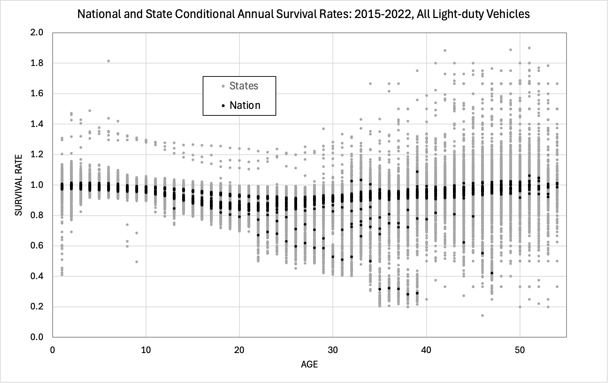
Figure 1. National and State Unedited Annual Net Survival Rates for All Light-duty Vehicles: 2015-2022
- Exploratory Analysis of Factors Affecting Net Survival Rates
Graphical analysis of net survival rates revealed that state net survival rates differed in important, systematic ways from national survival rates.
Graphical analysis
A sample of 6 states is shown in Figure 2, with the U.S. national rate represented by the dashed black line). Some states, especially in the South, Midwest and Mountain West have net survival rates higher than the national average for newer used vehicles. In Figure 2, Michigan, New York and California exhibit a sharp drop in net survival in year two while Texas and Alabama have sharp increases that exceed 1.0 (100%). Net survival rates exceeding 1.0 indicate net migration of vehicles into the state but net migration rates less than 1.0 reflect a combination of emigration and scrappage. All the curves decrease until 20-25 years of age and then increase. Beyond about 30 years, relatively few vehicles remain in operation and the net survival rates become noisier.
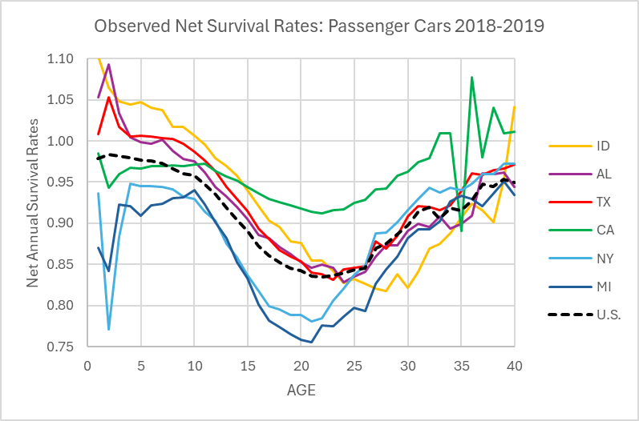
Figure 2. Observed Net Passenger Car Net Survival Rates for Six States and the U.S.: 2018-2019.

In addition to graphing state net survival rates, we mapped an indicator of cumulative net imports for all states, defined as net imports minus exports. As we have stated above, the data do not differentiate between migration and scrappage. However, we can infer migration for relatively young vehicles since vehicle scrappage rates are close to 0% as few vehicles are scrapped in their early life. The estimated fraction of a-year-old vehicles in state s imported (f>0) or exported (f<0) in a given year is the difference between the state survival rate and the national survival rate: $r_{sv2,2019}=s_{v2,2019}-s_{sv2,2019}$. The corresponding fraction of y-year old (2≤y≤10) vehicles is estimated by the sum of imports or exports from 2 to y, weighted by their respective cumulative survival rates.
$$f_{sva,2019}=\sum_{a=2}^{y}{r_{sva,2019}}\prod_{i=2}^{a}{s_{svi,2019}}$$
The results for the three vehicle types (Figures 3a-3c) indicate that a substantial fraction of newer used vehicles move from their states of origin to other states. The averages over states are 4.2%, 0.9% and 4.5% with standard deviations of 14.4%, 14.4% and 13.9%, respectively, for cars, pickups and SUVs and vans. California, New York, Illinois, Pennsylvania, Michigan are consistently net exporters, while Southeast, Midwest and Mountain states tend to be net importers of 2- to 10-year old used vehicles.

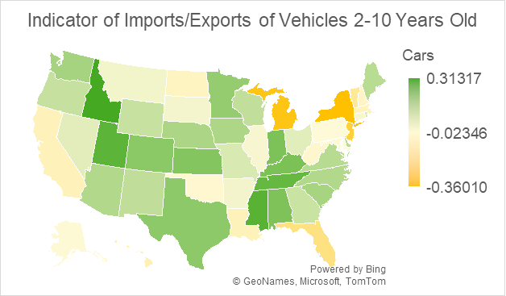
Figure 3c. Indicator of net imports of 2- to 10-year-old used passenger cars in 2019.

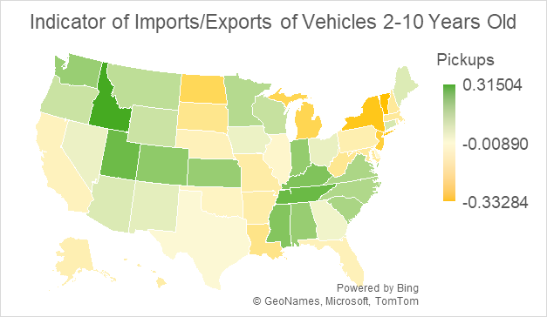
Figure 3c. Indicator of net imports of 2- to 10-year-old used pickups in 2019.
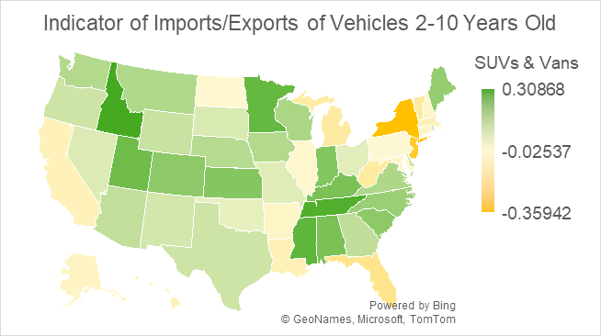
Figure 3c. Indicator of net imports of 2- to 10-year-old used SUVs and vans in 2019.
Variables explaining variation in net survival rates
Vehicle survival, scrappage and migrations do not appear to have been previously analyzed at the state level. Given the lack of prior research, we first explored the relationship of a set of potential explanatory variables to net survival rates. For this exploratory analysis, we used state data for only 2018-2019 net survival rates and averaged state net survival rates for five age groups: 0 to 3, 4 to 9, 10 to 15, 16 to 25 and >25 years old. These groupings were chosen to represent different aspects of the used vehicle market. At two and three years old, vehicles owned by rental companies and held by individuals on leases are typically offered for sale as used vehicles. New car dealers are most active in this market segment (Cox Automotive, 2021). Non-manufacturer-franchised used car dealers are most active in the market for 4 to 9-year-old vehicles. Online retail services are active in both markets. Beyond nine years, the used vehicle market is a mixture of used vehicle dealers, on-line sales and person-to-person transactions.
True scrappage rates are low (1% to 5%) for vehicles less than nine years old (Figure 2). Scrappage of the youngest used vehicles is typically caused by infrequent, severe accident damage or other catastrophic events. Scrappage rates increase rapidly for vehicles from nine years old to 20 to 25 years of age and tend to decrease thereafter (Greene and Leard, 2024a). Therefore, we expect differences in net survival rates for younger used vehicles will be strongly influenced by migrations of vehicles from one state to another. Differences in net survival rates for vehicles aged 10 to 25, when net survival rates decline fastest, should also reflect differences in wear and tear due to usage and environmental factors. By dividing the statistical analysis into age groups, we hoped to identify differences in the factors affecting net survival as vehicles age. Scrappage rates as a function of age have also been shown to vary by vehicle types (Greene and Leard, 2024a). We divided light-duty vehicles into the same three vehicle types as that study: passenger cars, SUVs and vans, and pickup trucks.
We assembled indicators for categories of potential determinants of net survival rates: economic, demographic, geographic, consumer preferences and vehicle wear and tear. In the economic category, we include growth in disposable income, state GDP and employment, and two measures of the distribution of wealth, median household income and the share of income of the top income decile. Geographic variables include population density and the fraction of population living in rural areas. Demographic variables include growth in the driving age (over 16) population and net migration. The indices of income distribution are also expected to influence preferences for new and used vehicles, and to those we added the percent of new cars that were leased rather than purchased, the percent of the population with a bachelor’s degree or higher and the percent without a high school diploma. We represent wear and tear by average annual miles per vehicle, annual road salt usage, traffic fatalities per 100,000 vehicles, and percent of Interstate Highway miles frequently congested. For the variable selection regressions, we define the dependent variable as the average age group net survival rate for each vehicle class for each state from 2018 to 2019 minus the national survival rate.
We used the Stata™ lasso software for variable selection. The lasso procedure minimizes the sum of squared errors of potential models as does OLS regression, but subject to a constraint that penalizes the weighted sum of coefficients included in the model. Variables are standardized prior to analysis. Separate analyses were run for each of the three vehicle classes. We used the Stata™ procedure’s default assumptions designed for variable selection. Determination of the parameters of the weighting constraint includes obtaining a random seed. A consequence of this is that if the data does not strongly suggest a particular set of variables, a subsequent run using the same data may produce different results. We ran the lasso analysis twice and found this to be the case for the youngest (0-3) and oldest (>25) vehicle age categories.
The results of the lasso analysis are summarized in Table 1. Shading indicates a variable was selected in both runs while no shading indicates selection in only one of the two runs. Plus signs indicate a positive relationship and minus signs negative. The two runs consistently agreed on the signs of selected variables. Growth of the driving age population includes both migration into the state and indigenous population growth. It was estimated to increase net survival rates and was selected for three age categories for each vehicle type. It appears to dominate net migration which was selected only twice by both runs and only for older vehicles. Higher population density was selected only for the three middle age categories with a negative effect on net survival rates. The estimation of net survival models presented in the following section will show that population density’s effect switches sign when state fixed effects are included in the model. We expect economic growth to induce both migration of vehicles into a state and increased indigenous demand for vehicles. Growth in employment was selected more frequently than GDP growth, but both have a positive effect on net survival rates. Other economic variables showed less consistent associations with net survival rates. We hypothesized that higher lease rates would increase the supply of relatively newer vehicles for export to other states. Except for the oldest age group, lease rates were associated with lower net survival rates even for older vehicles, a result generally consistent with our expectations that leased vehicles would be a source of exports. The fraction of the population holding a bachelor’s or advance degree was associated with reduced net survival rates for older vehicles, suggesting a correlation between higher education and preference for younger vehicles. Finally, indicators of wear and tear were selected only for older age groups, and with generally negative effects on net survival rates.

 | Passenger Cars |  |  |  |  | SUVs |  |  |  |  | Pickup Trucks
Variable / Age | 0-3 | 4-9 | 10-15 | 16-25 | >25 | 0-3 | 4-9 | 10-15 | 16-25 | >25 | 0-3 | 4-9 | 10-15 | 16-25 | >25
Demographic
DrivingAgePop | + | + | + |  |  | + | + | + |  |  | + | + |  | +
NetMigration |  |  |  | - | - |  |  |  | - |  |  |  |  |  | -
PopDensity |  | - |  | - |  |  | - | - | - |  |  | - | - | -
RuralPct | + |  |  |  |  | + |  | - | - |  | + |  | - | -
Economic
JobGrowth |  |  | + | + | + |  |  | + | + |  |  | + | + | + | +
GDPGrowth |  | + | + | + |  |  |  | + | + | + | + |  |  |  | +
PCDispIncGr |  |  |  | + | +
MedianIncome |  |  |  | + | + |  | - |  | + |  |  | -
Top10%Income |  |  |  |  | + |  |  |  |  | +
Market
LeaseIndex | - | - | - | - | + | - | - | - | - | + | - |  | - | -
%CollegeDeg |  | - | - | - |  |  |  | - | - |  |  |  | - | -
%NoDegree
Wear & Tear
TrafficCongest |  |  |  |  |  |  |  |  |  |  |  |  | +
FatalityRate |  |  |  | + | - |  |  |  |  | -
Miles/Vehicle |  |  |  | - | + |  |  | - | - |  |  |  | +
SaltUse |  |  | - | - | + |  |  | - | - | + |  |  | - | -
Table 1. Summary of lasso variable selection analysis of 2018-2019 state vehicle net survival data.
Notes: a + sign indicates a positive effect on net survival, a – sign a negative effect. Shading, whether dark (+) or light (-) indicates both lasso runs selected the variable and both runs found the effect to have the same sign. Plus or minus signs with no shading indicate that only one of the lasso runs selected the variable.

- Specification of Models of State Net Survival Rates
We now extend our state net vehicle survival rate analysis by estimating statistical models that could be useful for predicting the future evolution of used vehicle fleets at the state level. For practicality, such models should be driven by factors that are predictable with acceptable errors, or that can be reasonably constructed for scenario analysis. Variables like state population, income and employment will vary over time, and credible forecasts of these variables are available from various sources. Variables like percent of new car sales that are leases or percent of the population with a bachelor’s degree or higher, could be forecasted, but state-level forecasts of these variables are not readily available. Most such variables either vary little and slowly over time or may vary unpredictably around a mean value that changes slowly over time (e.g., salt use on roadways). This suggests estimating state-level net survival functions including demographic and economic factors for which forecasts are readily available as continuous variables, representing persistent state attributes with state fixed effects and representing unsystematic temporal shocks, such as the COVID pandemic, with year fixed effects. In initial estimations, we found that given state and temporal fixed effects, only a few continuous variables could be nominally statistically significant.
We selected the following state net survival model formulation which we estimated separately for the three vehicle types, for vehicles more than 1 year old and less than 41 years old. In each model, the dependent variable is the net survival rate, $r_{jast}$, $j$ denotes vehicle body style (car, SUV & van, pickup), $a$ denotes vehicle age, $s$ denotes state, and $t$ is the year pair (2015/2014 to 2022/2021). We include the following explanatory variables:
1) natural logarithm of vehicle age (lnAge),
2) state annual growth rate of population over 16 years of age (dPop16),
3) state annual employment growth rate (dEmp),
4) state annual population density (Density).

We include the following fixed effects: age, state, year. We include several interactions, including state fixed effect $c_{js}$ with log of vehicle age, $lnAge_{jst}$ and COVID with selected vehicle ages. This allows the marginal effect of the state-age interaction to decrease with increasing age. Our model is
$r_{jast}=b_{1}{dGDP}_{st}+b_{2}{dPop16}_{st}+b_{3}{dEmp}_{st}+b_{4}{Density}_{st}+c_{ja}+c_{js}+c_{jt}+c_{js}{lnAge}_{jst}+ε_{jast}$ (3)
State GDP and employment data are from the U.S. Bureau of Economic Analysis (BEA, 2024), population and land area data are from the U.S. Census Bureau (2024a, 2024b, 2024c, 2024d) and population density was calculated by dividing state population by land area. We expect income and employment growth to increase migration of used vehicles into the state as well as the demand for used vehicles and therefore increase net survival rates.
We reasoned that the effects of economic and demographic variables on net survival rates would decrease with increasing vehicle age. Used vehicle prices tend to decrease at approximately 10% per year and we hypothesized that the propensity to migrate with or ship a vehicle from state to state might vary with its value. The regression estimates indicated that weighting the demographic and economic variables by 0.9^{age} did improve the fit of the model to the data.
The proposed model does not include used or new vehicle prices because a time series of state-level prices for light-duty vehicles was not available. Instead, we included year fixed effects which precludes estimating price effects based on national data.
We do not include state-specific annual shock effects because including them would require adding 350 additional fixed effects to the 110 age, state, year and COVID fixed effects and would create identification and multicollinearity problems with the state demographic and economic variables that also vary with by and year.
Inspection of residuals from the regression and the corresponding net survival data for the state of Tennessee revealed that the Tennessee data were outliers for the year pair 2015/2014 for every vehicle type and age and were inconsistent with the state’s net survival rates in other years. An indicator variable was included for that year and state in each vehicle type regression. In addition, data for the District of Columbia appeared to be erratic, frequently including extreme outliers, and we excluded DC data from the state net survival function estimations.
Although the net survival rate data include vehicle ages up to at least 50 years, vehicles older than 40 years of age were excluded from the estimation of state-level net survival functions for several reasons. The variance of net survival rates increases greatly as vehicle age increases while the number of vehicles in operation decreases greatly due to attrition (we include the older ages and outliers in the residual plots shown below).
Finally, graphical analysis of the national and state data revealed that net survival rates for the year 2021 (from December 31, 2020, to December 31, 2021) were highly unusual for vehicles older than 20 years. Net survival rates for older vehicles dropped sharply, as illustrated by the dashed line in Figure 4. Inspection of the state data indicated that this was not a problem of missing data from some states. All states showed similar though not identical unusual decreases in net survival rates for older vehicles in 2021. The year 2021 was the height of the COVID-19 pandemic in the United States. The Center for Disease Control (2022) estimated that COVID-19 caused 460,513 deaths in that year. We reasoned that, in addition to the increased deaths of vehicle owners, the economic downturn and financial uncertainties caused by the pandemic may have led many owners of older vehicles to elect not to register or insure vehicles not essential to their travel needs. U.S. vehicle travel statistics show an unprecedented decrease of 11% in vehicle miles of travel from 2020 to 2021 (FHWA, 2023). Based on an examination of residuals, we included fixed effects for 2021 for ages 26 to 40 for passenger cars, SUVs and vans, and 22 to 40 for pickup trucks. These coefficients vary by vehicle type but not by state.
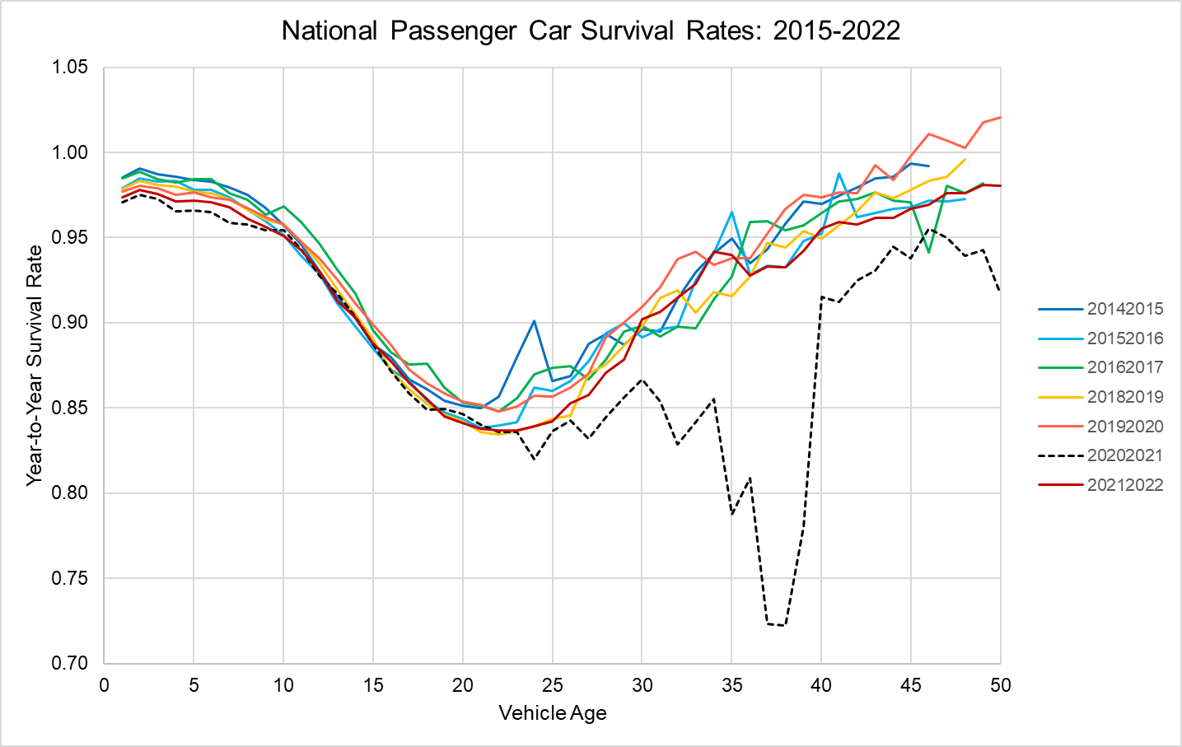
Figure 4. National Passenger Car Net Survival Rates: 2015-2022.

Initial estimations of the net survival functions were made including all data points for the sample described above. For the final estimations, observations with residuals greater than 5 times the mean standard error in the initial estimation (0.18 for passenger cars, 0.235 for SUVs and vans, 0.22 for pickup trucks) were dropped from the sample. The relatively large values for screening outliers were chosen because of the increasing variances of residuals with vehicle age. Out of 15,600 total observations for each vehicle type, this resulted in dropping 54 observations for cars, 71 for SUVs and vans, and 29 for pickup trucks.

- Results
We estimated the three state net survival models for passenger cars, SUVs and vans, and pickups using OLS. Because the variance of residuals increases markedly with age beyond 30 years, we included robust standard errors in all regressions. The estimation results appear in Table 2. In general, the estimated models statistically explained most of the variance in the net survival data, with adjusted R² values and mean square errors of 0.82 and 0.030 respectively for passenger cars, 0.75 and 0.041 for SUVs and vans, and 0.92 and 0.035 for pickup trucks. The residual plots appearing in Figures 5a-5c include outliers and indicate that the models’ fit to the data is much better for ages up to 25-30 years than for older vehicles.
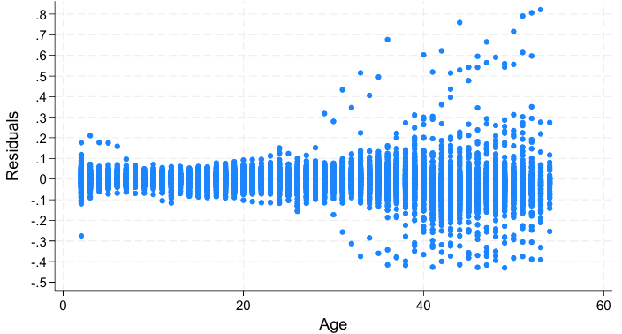
Figure 5a. Residuals from the State Passenger Car Net Survival Model

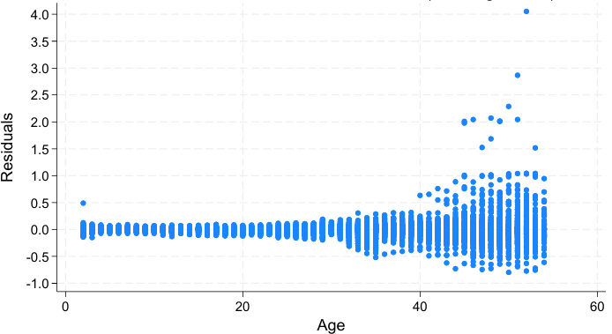
Figure 5b. Residuals from the State SUV and Van Net Survival Model

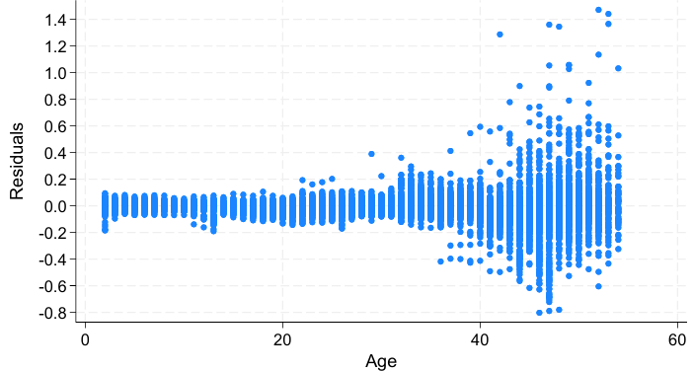
Figure 5c. Residuals from the State Pickup Truck Net Survival Model
As expected, higher economic and employment growth rates, and faster population growth increased net survival rates. In the SUV and van model, GDP growth replaced population growth. Population density appears in all models, but with a positive sign in the presence of state fixed effects. Removing the state fixed effects changes the sign of population density, reflecting the correlation between density and state fixed effects. To the extent that the state fixed effects capture the effect of mean population density, the density variable represents total population growth. Recognizing that the significance levels are not valid for hypothesis testing, the continuous variables in all models had estimated p-values of 0.001 except for the growth of population over 16 years old in the passenger car regression, which has a p-value of 0.05. The Stata “testparm” procedure calculated the combined age fixed effects to be significant at the 0.001 level, as were the state, year and COVID fixed effects and the (state)x(ln(Age)) interactions.
Coefficient estimates for Employment, Pop>16 (driving age population), GDP and Density plus the indicator variable for Tennessee in 2015 (TN2015) are shown in Table 2 for the Full Model and with individual fixed effects (FE) removed. In the Full Model, all four variables have p-values at the 0.001 level with the exceptions of Pop>16 (p = 0.05) in the Passenger Car model.⁹ Removing the Year FE has the greatest impact on the p-values and signs of the estimates (except for TN2015) because Year represents the national impacts of changes in those variables and other omitted variables, such as prices, that change over time. When Year FEs are included the economic and demographic variables represent state differences in those variables from the national trends. When the Year FEs are removed, the correlations of the variables with the national trends affect their coefficient estimates, resulting in reduced statistical significance and a few sign changes, for example, the negative effect of employment. The impacts of removing the State fixed effects are smaller because the model still includes the natural log of age interacted with the State FEs, which adjusts to absorb most of the effect of the State FEs. Removing the Age FEs has a large effect on the R² values because the Age FEs describe the general tendency for net survival rates to vary with vehicle age and therefore the general shape of the net survival function. Removing the COVID FEs also has a large effect on R² because the net survival rates for older vehicles during 2021 were so different from those of other years. Removal of the COVID FEs also magnifies the coefficients of the economic variables because of COVID’s effect on the economy in 2021.
Table 2. Coefficients of the State Net Survival Model and the Impacts of Fixed Effects.
Variable | Full Model | Alternative Specifications Removing
 |  | Year FE | State FE | -Age FE | -COVID FE
Age | X | X | X |  | X
State | X | X |  | X | X
Year | X |  | X | X | X
COVID | X | X | X | X
Passenger Cars
Employment | 0.3807*** | -0.1619*** | 0.5881*** | 0.9470*** | 0.9798***
Pop > 16 | 0.0123*** | 0.0071* | 0.0180*** | 0.0162*** | 0.0153***
Density | 0.00058*** | 0.00054*** | -0.00009*** | 0.00273*** | 0.00062***
TN2015 | 0.3187*** | 0.3261*** | 0.3230*** | 0.3199*** | 0.3192***
R² | 0.8240 | 0.8152 | 0.7937 | 0.5791 | 0.7567
RMSE | 0.03016 | 0.03091 | 0.03261 | 0.04659 | 0.03545
SUVs and Vans
Employment | 0.3705*** | -0.3098*** | 0.4396*** | 0.5289*** | 0.5626***
GDP | 0.5434*** | 0.0656 | 0.4669*** | 0.9528*** | 1.2708***
Density | 0.00108*** | 0.00102*** | -0.0001*** | 0.00268*** | 0.00129***
TN2015 | 0.3320*** | 0.3397*** | 0.3368*** | 0.3328*** | 0.3323***
R² | 0.7577 | 0.7420 | 0.7230 | 0.6352 | 0.6606
RMSE | 0.04079 | 0.04209 | 0.04355 | 0.05000 | 0.04826
Pickups
Employment | 0.5191*** | -0.1207*** | 0.7288*** | 0.5397*** | 3.7680***
Pop > 16 | 0.00578* | 0.00021 | 0.01220*** | 0.00606 | 0.02178*
Density | 0.00080*** | 0.00076*** | -0.00006*** | 0.00124*** | 0.00101***
TN2015 | 0.3012*** | 0.3012*** | 0.3055*** | 0.3013*** | 0.3035***
R² | 0.9184 | 0.9141 | 0.9073 | 0.9023 | 0.5907
RMSE | 0.03477 | 0.03565 | 0.03700 | 0.03799 | 0.07781
Note: RMSE – root mean square error; FE – fixed effects. ***p<0.001, **p<0.01, *P<0.05

The resulting models reflect important differences in net survival rates across states that could be used to forecast future vehicle migrations. Estimated state net survival functions for the fifteen most populous states in 2024 are illustrated in Figures 6a-6c, showing the passenger car functions for the top 5, SUVs and vans for the next 5, and pickups for 11 to 15. The graphs show estimated annual net survival rates and cumulative net survival, the cumulative product of the annual rates. The cumulative curves must be interpreted with caution because they assume that the conditions existing in the year in question will continue indefinitely, which is not the case in general. While many states’ functions are similar, some important differences are evident. Some states appear to be importers of younger used vehicles (e.g., Georgia and North Carolina, Figure 6b, and Tennessee and Virginia, Figure 6c), with net survival rates close to or exceeding 1.0, while other states appear to be exporters with unrealistically low net survival rates for 2-10-year-old cars (e.g., New York for cars, Figure 6). The cumulative rates better illustrate tendencies to import or export vehicles. While there are some kinks in the annual rates, the effects are smoothed out considerably in the cumulative curves. Detailed examination of the state data indicates that the kinks in the estimated curves are not artifacts of the estimation but reflect the empirical data. Estimated net survival curves for 2016 for the states ranked 16-30th in population are compared in Figures 7a-7c. In general, states in the northeastern U.S. tend to be net vehicle exporters, while states in the south and mountain west tend to be net importers.
For most states, annual survival rates begin between 0.95 and 1.00 for 2-year-old vehicles and decline relatively slowly until about 10 years of age, after which survival rates decrease more rapidly. The decline slows approaching 20 years and reverses, increasing after about 22 years. Increasing survival rates (decreasing scrappage rates) for older vehicles were observed at the national level by Greene and Leard (2024a). The consistency in this pattern across states is partly attributable to the age fixed effects of the imposed model structure. However, the model allows state-specific effects of the logarithm of age that can shorten or lengthen the time when net survival rates begin to increase.
The cumulative net survival rates shown in the graphs are the cumulative product from 2, to 40 years of age of annual net survival rates, assuming the conditions in 2022 or 2016 continued. The cumulative curves represent what would happen if the given year’s rates persisted for 40 years, which is not realistic. Still, net survival rates even a small amount greater than 1.0, if they persist, can imply a large immigration of newer used vehicles into a state. For example, note SUVs and vans in Georgia and North Carolina in Figure 6b and pickups in Washington, Tennessee and Virginia in Figure 6c. Similar patterns can be seen for South Carolina, Alabama and Colorado in Figure 7b and Kentucky, Oregon and Utah in Figure 7c.

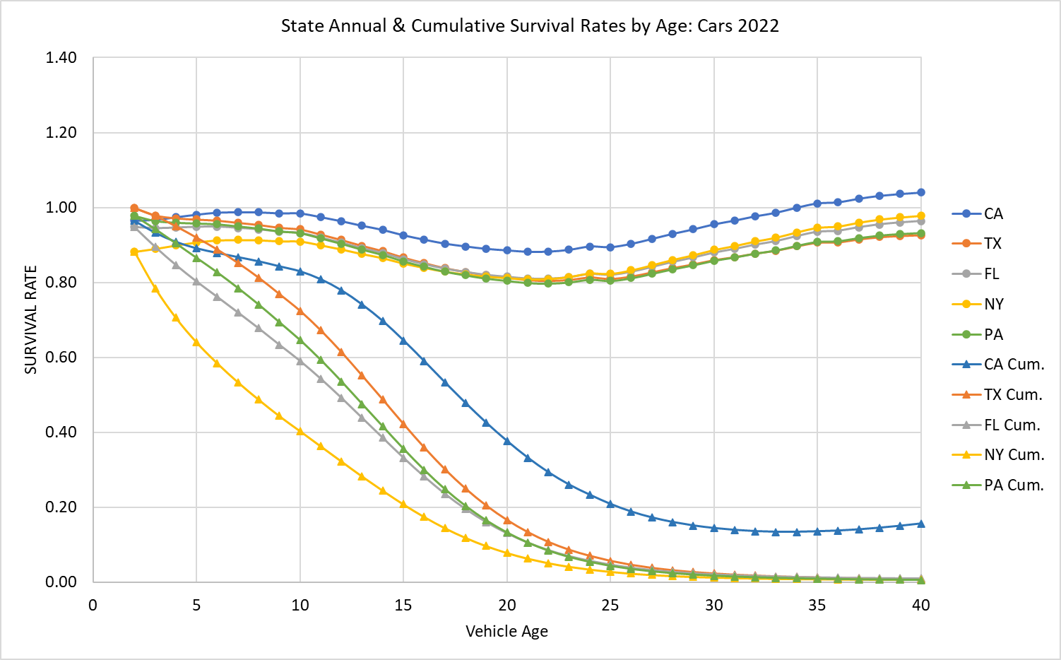
Figure 6a. Predicted Annual and Cumulative Net Survival Rates by Age for Five States: Cars 2022

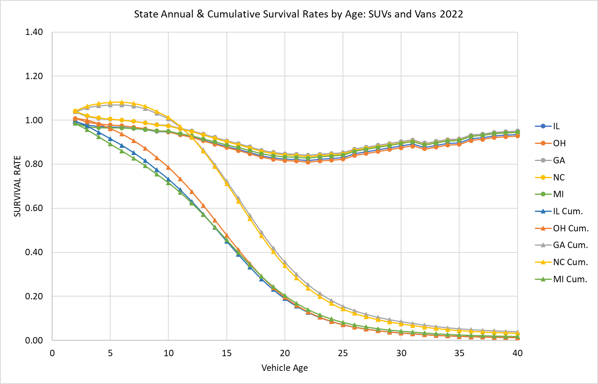
Figure 6b. Predicted Annual and Cumulative Net Survival Rates by Age for Five States: SUVs and Vans 2022

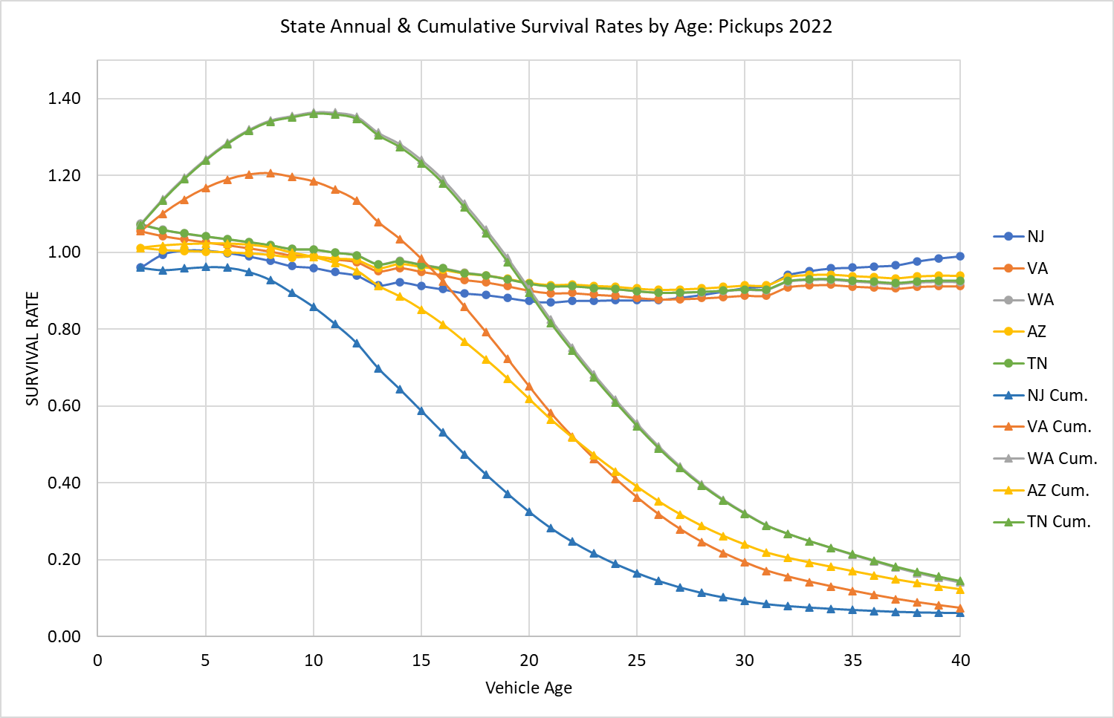
Figure 6c. Predicted Annual and Cumulative Net Survival Rates by Age for Five States: Pickups 2022

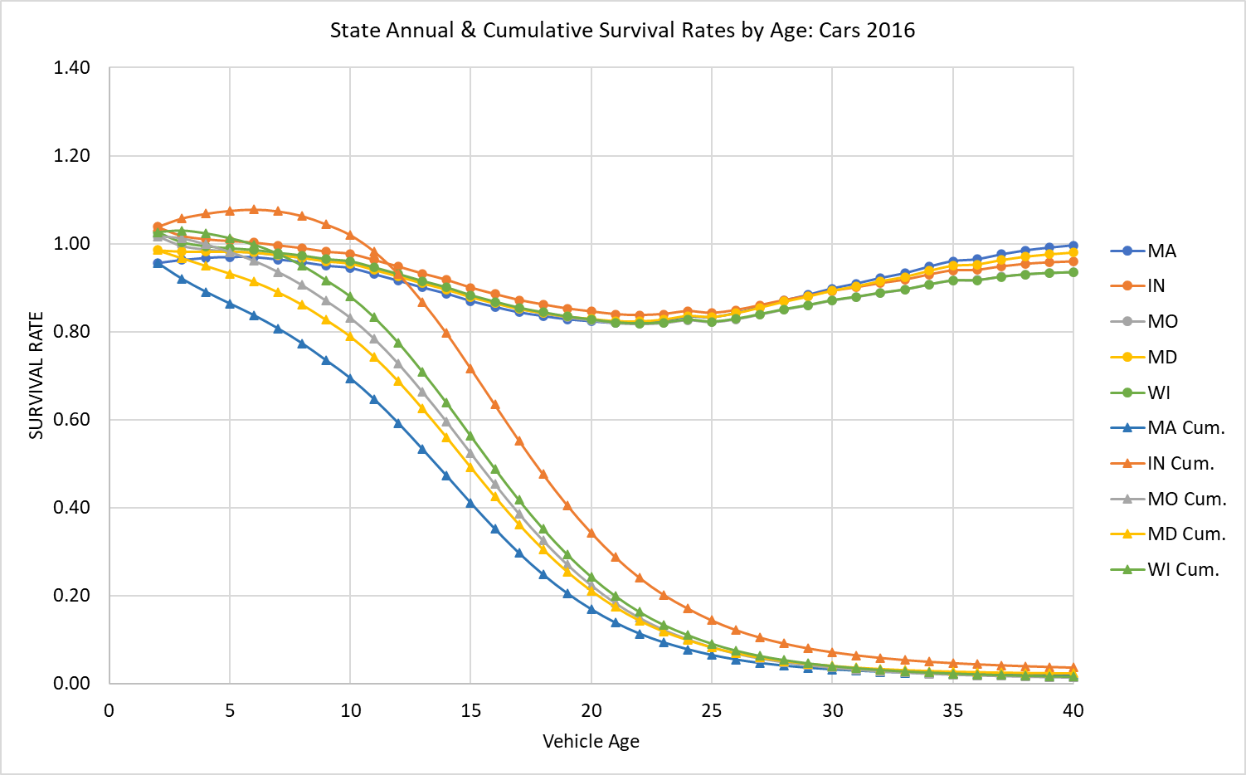
Figure 7a. Predicted Annual and Cumulative Net Survival Rates by Age for Five States: Passenger Cars 2016
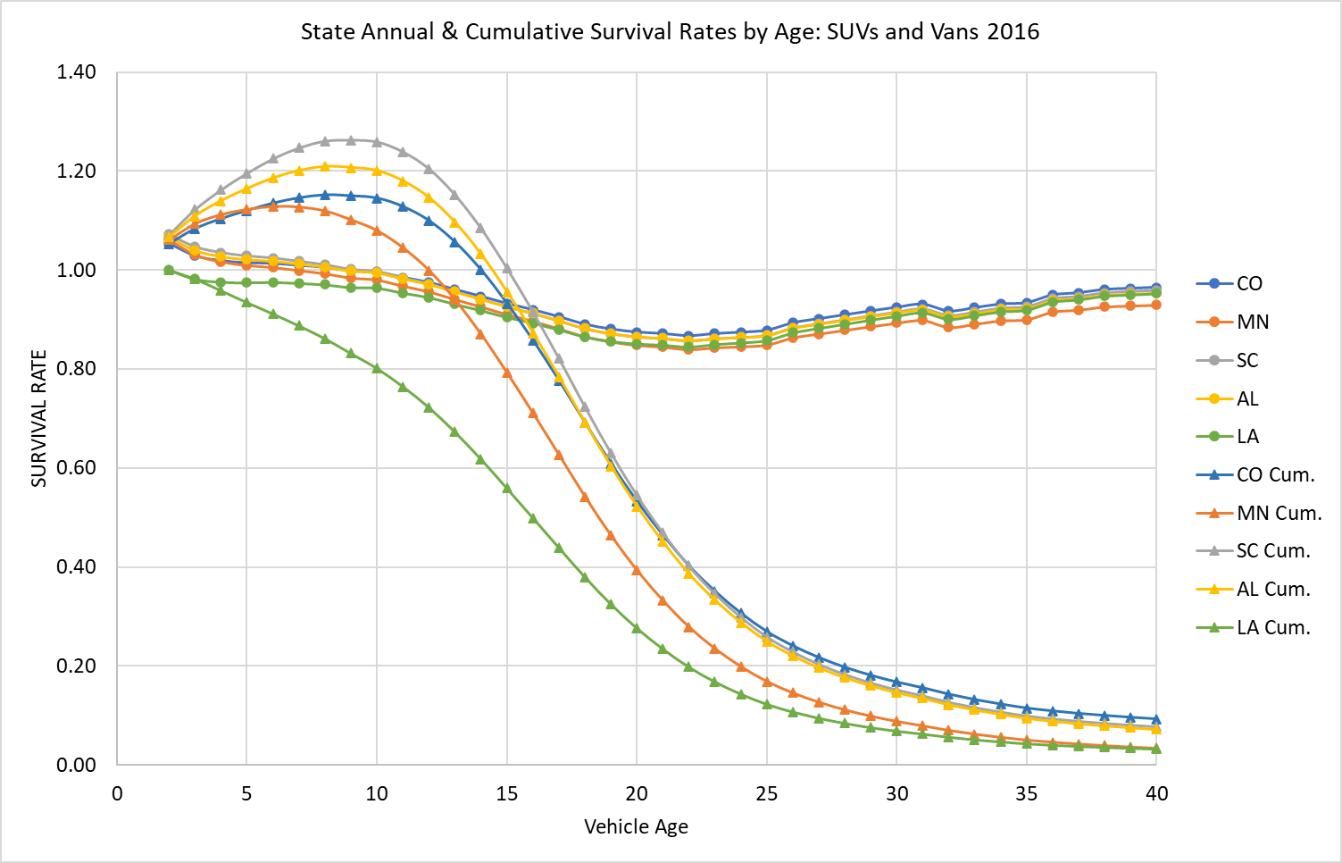
Figure 7b. Predicted Annual and Cumulative Net Survival Rates by Age for Five States: SUVs and Vans 2016
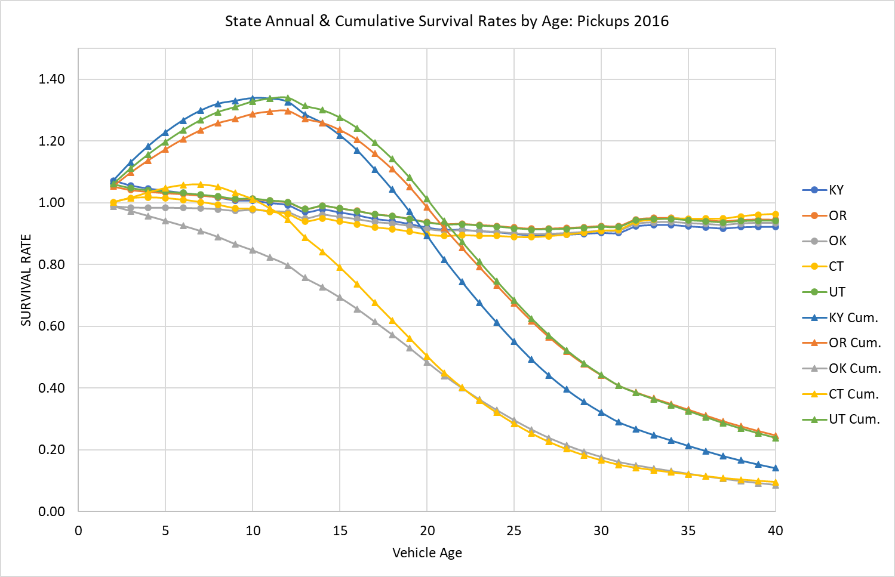
Figure 7c. Predicted Annual and Cumulative Net Survival Rates by Age for Five States: Pickups 2016

From 2010 to 2020, the populations of the Northeast and Midwest grew by 4.1% and 3.1%, respectively, while those of the West and South grew by 19.2% and 10.2%, respectively (U.S. Census, 2024), continuing a decades long pattern of migration that was interrupted by the COVID pandemic. Migrations of vehicles from the Northeast and Midwest to the West and South should be expected. Estimates for 2016 (Figure 8) show New York and New Jersey as donor states for pickups with unusually low net survival rates, and Tennessee, South Carolina and Alabama as receivers with unusually high net survival rates.

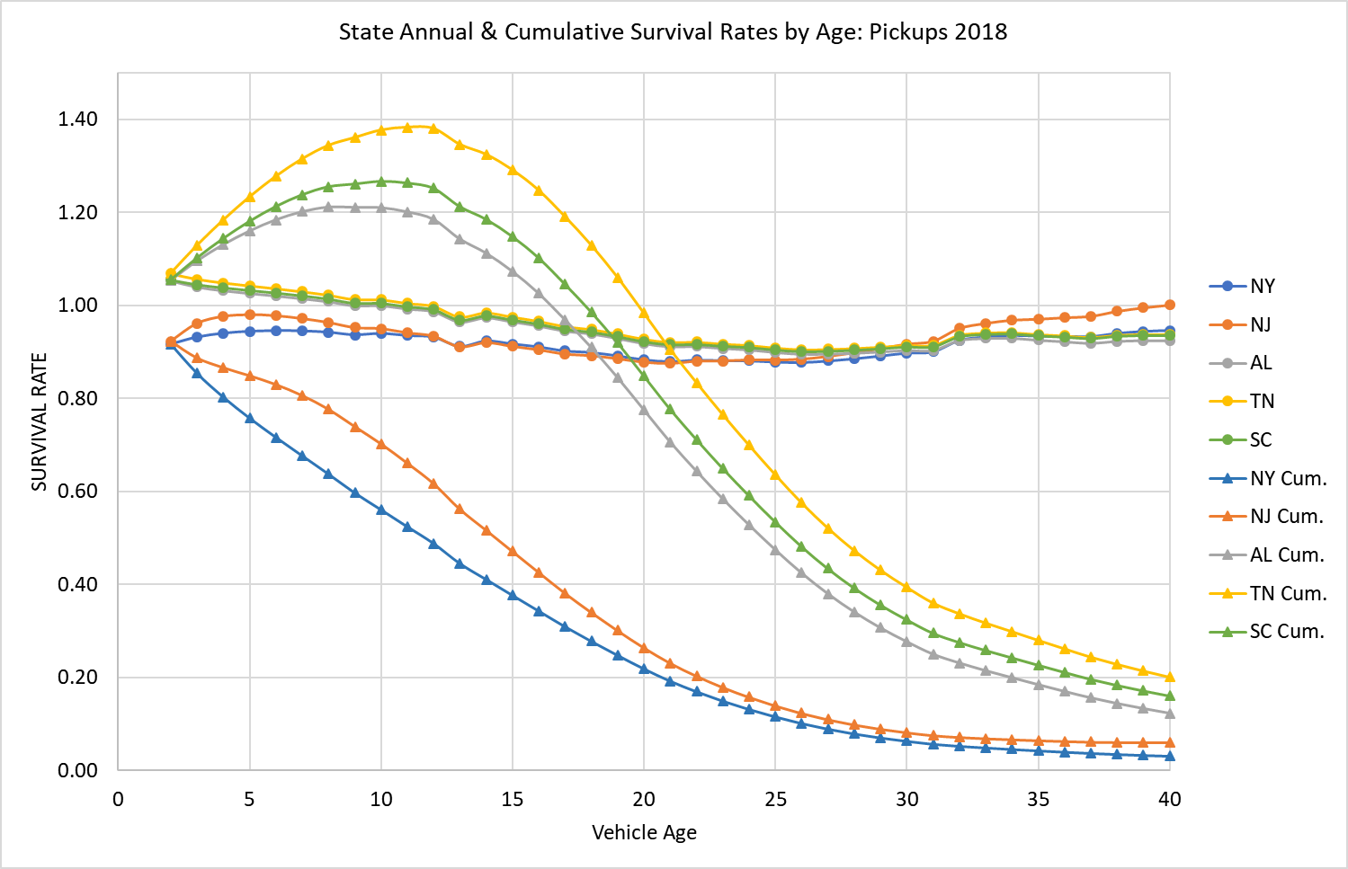
Figure 8. Apparent Import and Export States for Pickup Trucks: 2018.

Figures 9a-9c show estimated net survival curves for the same states as Figures 6a-6c, but for the peak pandemic year of 2021. The unprecedented changes caused by the global pandemic had a much smaller effect on the net survival rates of older passenger cars than on SUVs, vans and pickups. The drastic effects of the pandemic on older pickups may be due to their higher use in commerce.

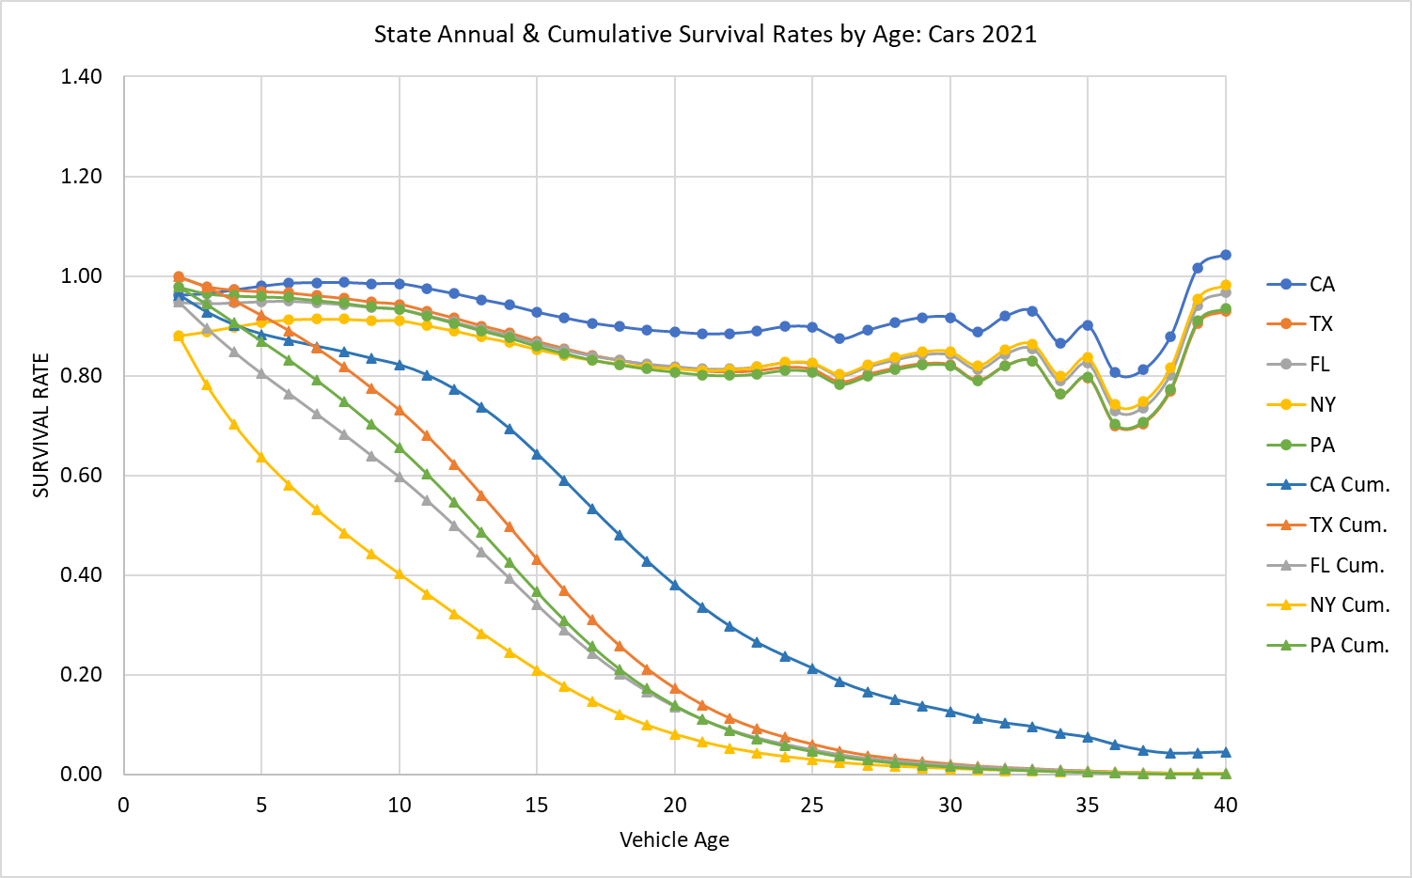
Figure 9a. Predicted Annual and Cumulative Net Survival Rates of Passenger Cars at the Height of the COVID Pandemic: 2021

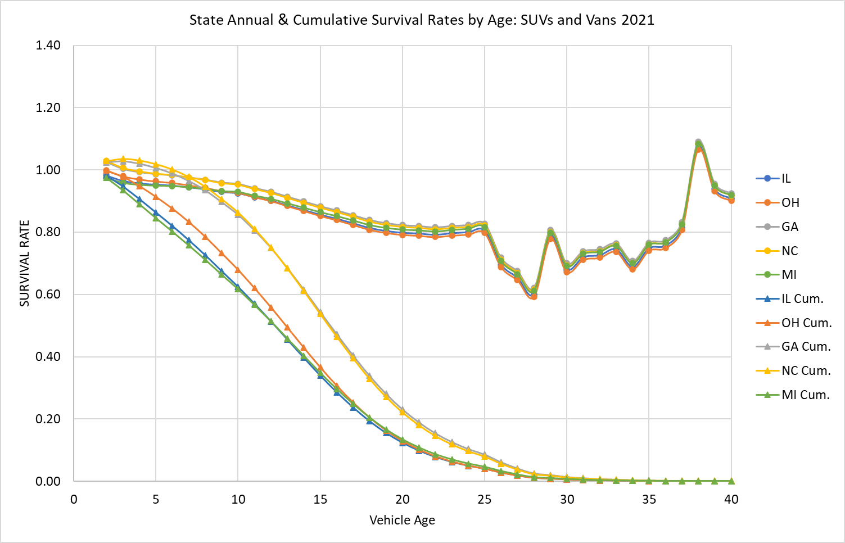
Figure 9b. Predicted Annual and Cumulative Net Survival Rates of SUVs and Vans at the Height of the COVID Pandemic: 2021
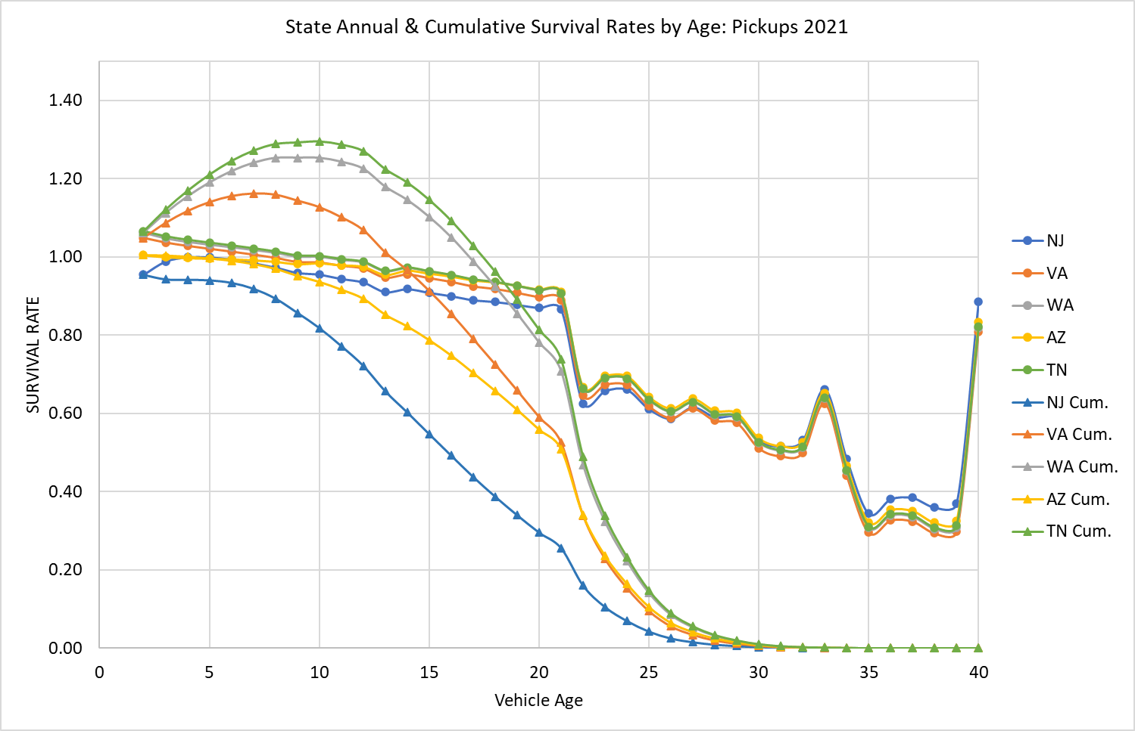
Figure 9c. Predicted Annual and Cumulative Net Survival Rates of Pickups at the Height of the COVID Pandemic: 2021
- Limitations
A limitation of our analysis is that the data available to us did not allow us to distinguish between flows of used vehicles from one state to another and differences in scrappage rates. If the patterns of flows are relatively stable over time, or if population and employment variables satisfactorily capture changes over time, the existing model formulation should produce reasonably accurate estimates of future used vehicle migrations. However, it may also be desirable to impose some restrictions on the projected state flows to ensure that used vehicles are not newly created or excessively destroyed. For example, neglecting net exports of used vehicles from the U.S., the sum of the total counts of state differences from national scrappage by vehicle type, age and year, must sum to zero. However, whether it is useful or important to constrain state net vehicle scrappage with a national function is not clear at present.
Although our lasso analysis indicated that many factors affect state net survival rates, only a few could be included in our statistical models of net survival. This is chiefly due to the inclusion of many fixed effects that better represent state attributes that change slowly over time, but it is also likely due to correlations among the economic and demographic variables.
While this limits the model’s usefulness for long-run forecasting it should improve its performance for forecasting a few years ahead. The state and age fixed effects represent the average fixed effects over the period on which the model was estimated (2016-2022). This is also true of state and log of age interaction coefficients, as well as the coefficients of employment, population and GDP. For forecasting, the COVID effects should be omitted, assuming a future pandemic is not forecasted. Because the year fixed effects represent the impacts of national temporal factors not fully reflected in the included variables it would not necessarily be best to use the year effect of the final year, 2022, for forecasting. The average of the year fixed effects, omitting the COVID year of 2021 might be a better option.
We do not have an obvious explanation for the positive effect of population density on net survival. It may represent population growth, reduced vehicle miles, or a greater propensity of urban and suburban consumers to prefer newer vehicles. Regardless, because of the correlation with state fixed effects, the models should not be used to predict the effects of large changes in population density.
There is no guarantee that the state models will produce the same survival rates as a single national survival function. However, if the sum of national used vehicle imports and exports is assumed to be zero, state projections can be constrained to sum to the projections of a national survival function.

- Conclusions
The research completed to date indicates that it is possible to construct useful state net survival models for cars, SUVs and vans, and pickup trucks. The state-level net survival models indicate that, even though not directly observed in our data, there are substantial movements of used vehicles, especially newer used vehicles from state to state. Many states have net survival rates greater than 1.0 for vehicles from 2 to 5 or even 10 years of age. Although the net survival effects in a single year are relatively small, e.g. single digit percents, the cumulative effect over five or ten years can be substantial. The models also suggest that state scrappage rates likely differ especially for older vehicles, due to usage and wear and tear.
Movements of used vehicles are likely to be important to understanding transitions to electric vehicles because of the large differences in registrations per capita across states, and because migrations of used EVs will affect the rate of innovation diffusion and the geography of electricity demand. Such effects would be missed using a single national survival function for all states. Effectively modeling the transition to electric vehicles will also require separately tracking all-electric, PHEV, and perhaps fuel cell and hybrid electric vehicles. Because mass-produced plug-in vehicles are a relatively recent phenomenon and their technology, product offerings, and supporting infrastructure have been rapidly evolving, it is not yet possible to confidently estimate complete survival functions for them at this time.
Differences in vehicle scrappage and survival, and the migrations of used vehicles from state-to-state is an aspect of the vehicle market that has received little attention. This study has shown that differences in state vehicle net survival rates can be modeled statistically, that there are substantial differences across states due to immigration and emigration of vehicles and differences in state scrappage rates. Additional research, using more detailed data is needed to distinguish vehicle migrations from scrappage, as well as to distinguish between electric and internal combustion vehicles.

- References
- Alberini, A., M. Bareit, M. Filippini, A.L. Martinez-Cruz, 2018. “The impact of emissions-based taxes on the retirement of used and inefficient vehicles: The case of Switzerland,” Journal of Environmental Economics and Management, 88: 234-258.
- Alliance for Automotive Innovation (AAI), 2025. “Get Connected: Electric Vehicle Quarterly Report,” Third Quarter 2024. https://www.autosinnovate.org/posts/papers-reports/get-connected-q3-2024.
- M. Sackey, P. Andoh, 2021. “Vehicle regulations in Africa: Impact on used vehicle import and new vehicle sales”. Transportation Research Interdisciplinary Perspectives, 10. https://doi.org/10.1016/j.trip.2021.100384.
- Bento, A., K. Roth and Y. Zuo, 2018. “Vehicle Lifetime and Scrappage Behavior: Trends in the U.S. Car Market,” The Energy Journal, 39(1): 159-183.
https://www.researchgate.net/publication/322177636_Vehicle_Lifetime_Trends_and_Scrappage_Behavior_in_the_US_Used_Car_Market
- Burra, L., M. Kasawaneh and C. Cirillo, 2024. “Impact of charging infrastructure on electric vehicle adoption: A synthetic population approach,” Travel Behaviour and Society, 37 (2024). https://doi.org/10.1016/j.tbs.2024.100834.
- Chen, L., B. Garcia-Medina, and R. Wan, 2019. “Trade liberalization, consumption shifting and pollution: Evidence from Mexico's used vehicle imports”. Review of International Economics, 27:1591-1608. https://doi.org/10.1111/roie.12436.
- Clerides, S., 2008. “Gains from trade in used goods: Evidence from automobiles”. Journal of International Economics, 76(2):322-336. https://doi.org/10.1016/j.jinteco.2008.07.009 .
- Consumer Affairs, 2025. https://www.consumeraffairs.com/automotive/used-car-statistics.html.
- Cox Automotive, 2021. “Commentary: Independent Dealers are Poised to Thrive as Driving Force in Recovery,” https://www.coxautoinc.com/market-insights/commentary-independent-dealers-are-poised-to-thrive-as-driving-force-in-recovery/.
- Cramer, J., 1958. “The Depreciation and Mortality of Motor-Cars,” Royal Statistical Society. Journal. Series A: General, 121(1): 18–46. https://doi.org/10.2307/2342989.
- Davis, L. and M. Kahn, 2010. “International Trade in Used Vehicles: The Environmental Consequences of NAFTA”, American Economic Journal: Economic Policy, 2(4):58-82.
- Federal Highway Administration (FHWA), 2023. Traffic Volume Trends December 2023. https://www.fhwa.dot.gov/policyinformation/travel_monitoring/23dectvt/23dectvt.pdf.
- Fuse, M., H. Kosaka and S. Kashima, 2009. “Estimation of world trade for used automobiles”. Journal of Material Cycles and Waste Management, 11:348-357. https://doi.org/10.1007/s10163-009-0263-3.
- FRED, 2025. https://fred.stlouisfed.org/series/ALTSALES
- Greene, D.L. and B.P. Leard, 2024a. “Trends in scrappage and survival of U.S. light-duty vehicles,” Transportation Research A: Policy and Practice, 180: https://doi.org/10.1016/j.tra.2024.103982.
- Greene, D.L. and B.P. Leard, 2024b. “MA3T Used Vehicle Model Documentation,” unpublished manuscript of March 27, 2024, available from the authors. Baker School of Public Policy and Public Affairs, University of Tennessee, Knoxville, TN.
- Greene, D.L. and B.P. Leard, 2024c. “Enhancements to the ORNL MA3T Used Vehicle Model to Enable Analysis of Taxes, Subsidies and Other Policies Directed at Used Vehicles,” Unpublished project report, available from the authors, Baker School of Public Policy and Public Affairs, University of Tennessee, Knoxville, TN.
- Greene, D., E. Kontou, B. Borlaug, A. Brooker, M. Muratori, 2020. “Public charging infrastructure for electric vehicles: What is it worth?,” Transportation Research D, vol. 78: 102182, https://doi.org/10.1016/j.trd.2019.11.011.
- Greenspan, A. and D. Cohen, 1999. “Motor Vehicle Stocks, Scrappage and Sales,” Review of Economics and Statistics, 81(3): 369-383.
https://www.jstor.org/stable/2646761?seq=1
- Hawley, R.E., 2024. “Car depreciation: What it is and how it works,” Bankrate. https://www.bankrate.com/insurance/car/understanding-car-depreciation/.
- Jacobsen, M., R. Beach, C. Cowell, and J. Fletcher, 2021. “The Effects of New-Vehicle Price Changes on New- and Used-Vehicle Markets and Scrappage,” EPA-420-R-21-019, U.S. Environmental Protection Agency, Office of Transportation and Air Quality, https://cfpub.epa.gov/si/si_public_record_Report.cfm?dirEntryId=352754&Lab=OTAQ .
- Jacobsen, M.R. and A.A. van Benthem, 2015. “Vehicle Scrappage and Gasoline Policy,” American Economic Review, 105(3): 1312-1338.
- Junk Car Reaper, 2024. “Average Vehicle Lifespan in the USA: A State-by-State Analysis”, internet article accessed at https://www.junkcarreaper.com/guides/vehicle-lifespans/ on 6/11/2025.
- Leard, B. and D. Greene, 2023. “Coordinating the Electric Vehicle Transition and Electricity Grid Decarbonization in the U.S. is Not Essential to Achieving Substantial Long-Term Carbon Dioxide Emissions Reductions,” Environmental Research Letters, 18(7), 074035. https://iopscience.iop.org/article/10.1088/1748-9326/acdd85.
- Lin, Z., D. Greene and J. Ward, 2025. User Guide of the ORNL MA3T Model (V20130729). Available at teem.ornl.gov/ma3t.shtml.
- Newman, S., K. Schulte, M. Morellini, C. Rahal and D. Leasure, 2024. “Offshoring emissions through used vehicle exports”. nature climate change, 14:238-241. https://doi.org/10.1038/s41558-024-01943-1
- Nieuwenhusi, P., A. Beresford and P. Choi, 2007. “Shipping Air? Tracking and Forecasting the Global Shipments of New and Used Cars”. IV(3): 17-36. ISSN: 1697-4840.
- Olguín, F., G. Iskakov and A. Kendall, 2023. “US-Mexico second-hand electric vehicle trade: Battery circularity and end-of-life policy implications”, Transportation Research D: Transport and Environment, 125. https://doi.org/10.1016/j.trd.2023.103934.
- Parks, R., 1977. “Determinants of Scrapping Rates for Postwar Vintage Automobiles,” Econometrica, 45(5), 1099-1115. https://www.jstor.org/stable/1914061.
- Shi, Y., T. Arthanari, V. Venkatesh, S. Islam and V. Mani, 2022. “Used vehicle global supply chains: perspectives on a direct-import model”. Supply Chain Management: An International Journal. 27(3): 333–347. https://doi.org/10.1108/SCM-06-2020-0238.
- Stata Corp., 2025. Stata 19 Lasso Reference Manual, College Station Texas, Stata Press.
- Tibshirani, R., 1996. “Regression Shrinkage and Selection Via the Lasso”, Journal of the Royal Statistical Society: Series B (Methodological), 58(1):267–288, https://doi.org/10.1111/j.2517-6161.1996.tb02080.x
- U.S. Census Bureau, 2024a. State-to-State Migration Flows. “Table 1. State-to-State Migration Flows¹: 2023 American Community Survey 1-Year Estimates” by year, 11/2024. https://www.census.gov/data/tables/time-series/demo/geographic-mobility/state-to-state-migration.html.
- U.S. Census Bureau, 2024b. “State Population Totals and Components of Change: 2020-2023,” and “Annual Estimates of the Resident Population for the United States, Regions, States, the District of Columbia, and Puerto Rico: April 1, 2010, to July 1, 2019; April 1, 2020; and July 1, 2020.” https://www.census.gov/data/tables/time-series/demo/popest/2020s-state-total.html.
- U.S. Census Bureau, 2024c. “Historical Population Change Data (1910-2020).” https://www.census.gov/data/tables/time-series/dec/popchange-data-text.html.
- U.S. Census Bureau, 2024d. State Area Measurements and Internal Point Coordinates 2010, accessed at https://www.census.gov/geographies/reference-files/2010/geo/state-area.html .
- U.S. Bureau of Economic Analysis (BEA), 2024. Regional Data: GDP and Personal Income, “SASUMMARY State annual summary statistics: personal income, GDP, consumer spending, price indexes, and employment,” https://apps.bea.gov/itable/?ReqID=70&step=1#eyJhcHBpZCI6NzAsInN0ZXBzIjpbMSwyOSwyNSwzMV0sImRhdGEiOltbIlRhYmxlSWQiLCI2MDAiXSxbIk1ham9yX0FyZWEiLCIwIl1dfQ==.
- U.S. Department of Commerce, Bureau of the Census, Foreign Trade Division, TPIS Database USHS EXPORTS, Revised Statistics for 1989-2023, Unrevised Statistics for 2024. https://trade.gov/data-visualization/used-vehicle-trade-data-visualization.
- U.S. Department of Transportation, Bureau of Transportation Statistics, National Transportation Statistics 2025. https://www.bts.gov/topics/national-transportation-statistics, tables 1-11, 1-40 and 1-50.
- U.S. Energy Information Administration, 2022a. Transportation Sector Demand Module of the National Energy Modeling System: Model Documentation. Page 80. https://www.eia.gov/outlooks/aeo/nems/documentation/transportation/pdf/transportation-2022.pdf .
- U.S. Energy Information Administration (EIA) 2022b. “Annual Energy Outlook 2023 Planned modeling and data updates in the transportation sector”, presentation slides of the AEO2023 Transportation Working Group, September 15, 2022. https://www.eia.gov/outlooks/aeo/workinggroup/transportation/pdf/AEO2023-Presentation.pdf .
- Velten, E., C. Brauer, and J.-E. Thie, 2020. “Used vehicle trade and fleet composition in Europe”. Final report of the project “Used vehicle trade and fleet composition in Europe” on behalf of the EEA. Ecologic Institute and Fraunhofer Institute for Systems and Innovation Research ISI: Berlin, Karlsruhe.
- Walker, F., 1968. “Determinants of Auto Scrappage,” Review of Economics and Statistics, 50(4): 503- 506.

Appendix A. State Vehicle Net Survival Model Estimation Results
Passenger Cars
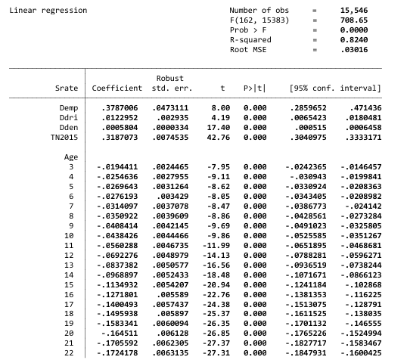
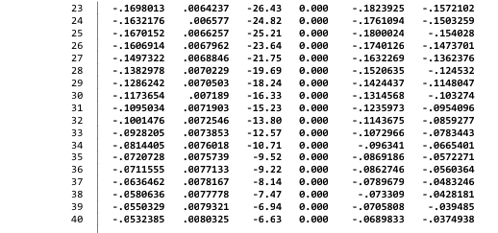

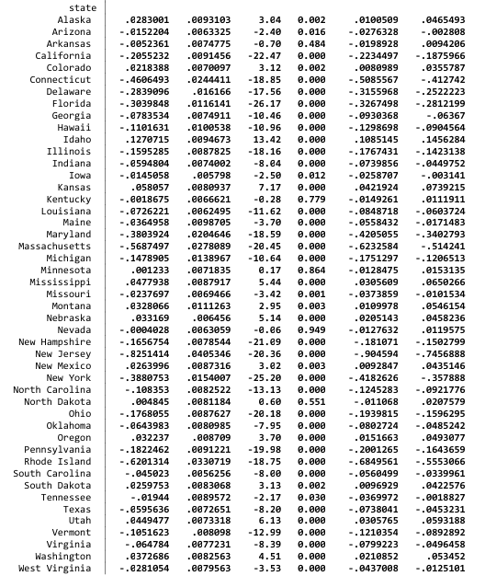
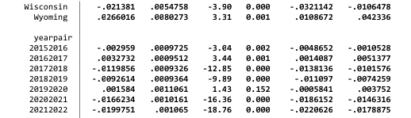

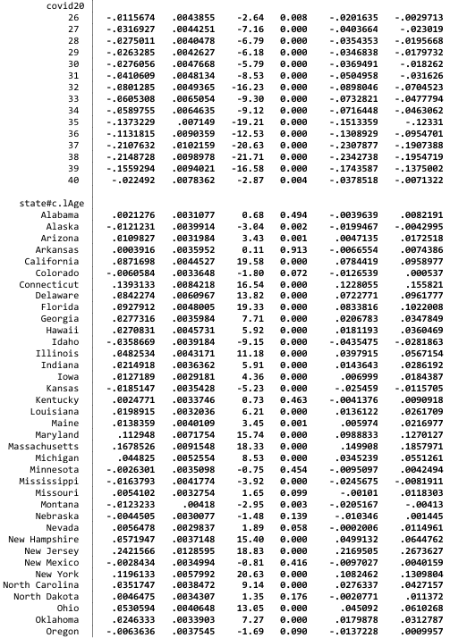
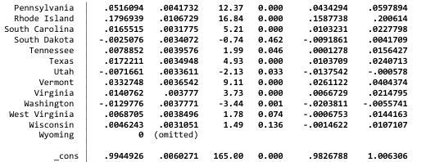

SUVs and Vans
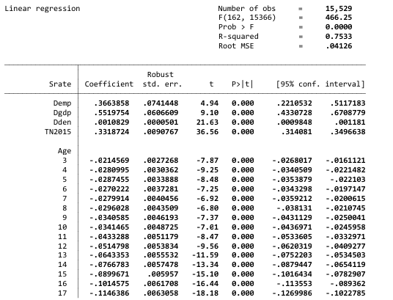
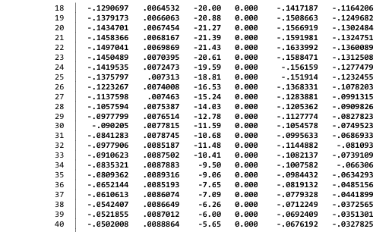

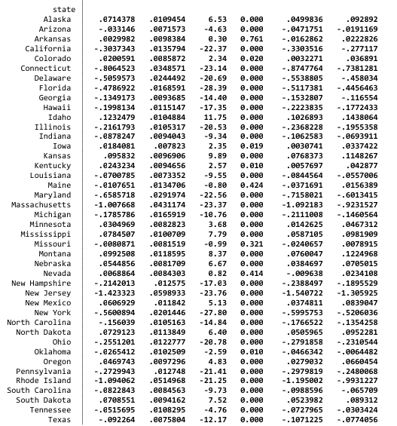
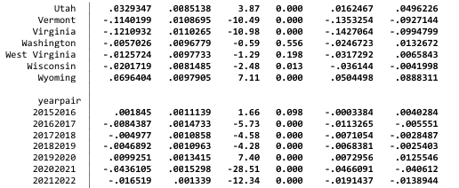

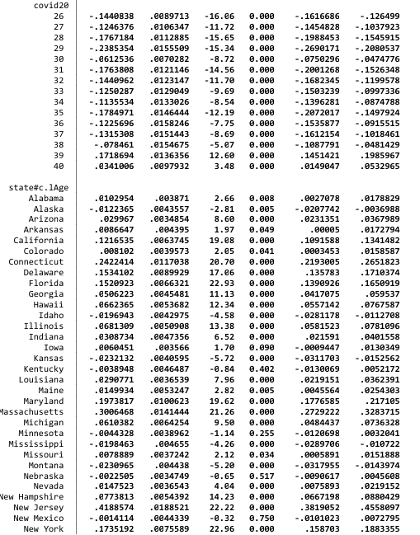
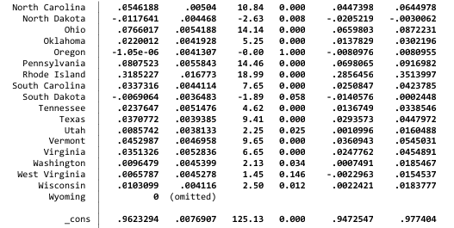

Pickups
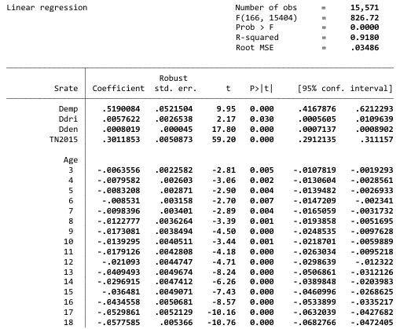
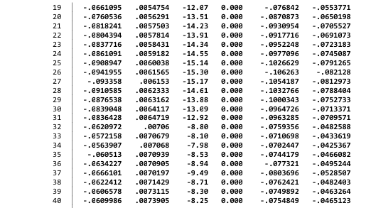

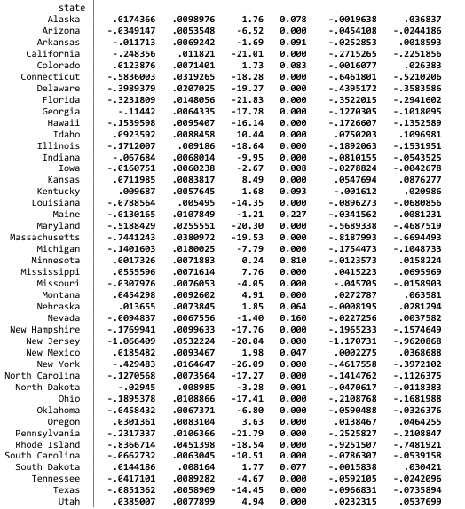
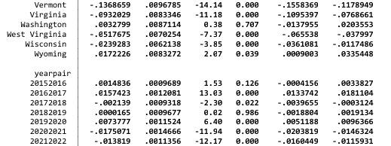

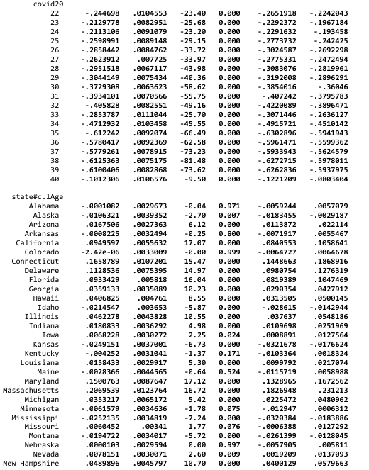
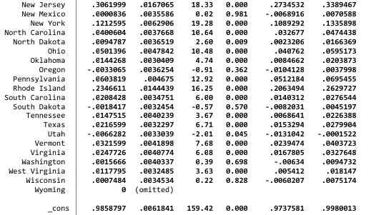

Appendix B. Graphs of State-level Cumulative Net Survival Rates by Vehicle Type: 2018 to 2019
The following graphs were created by Arthur Yip of the National Renewable Energy Laboratory to determine whether state scrappage rates varied across states and differed from national rates. The graphs reveal some striking differences. Some consistency is evident by state across the three vehicle types. States like Idaho, that have unusually high net survival rates for newer used passenger cars, also have high net survival rates for new SUVs and pickup trucks. The graphs provided the first evidence of systematic differences in net survival rates among states.
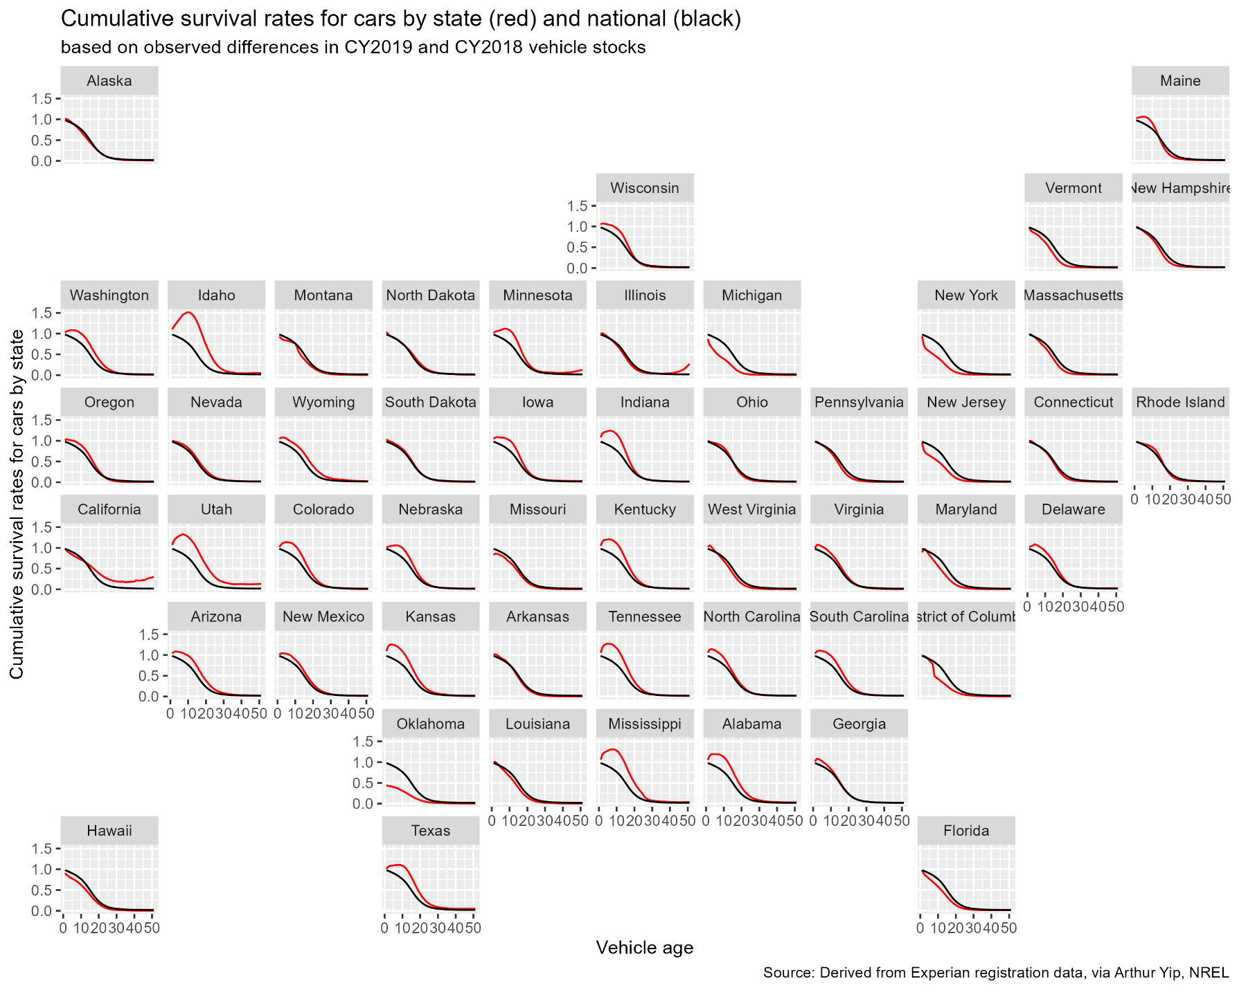
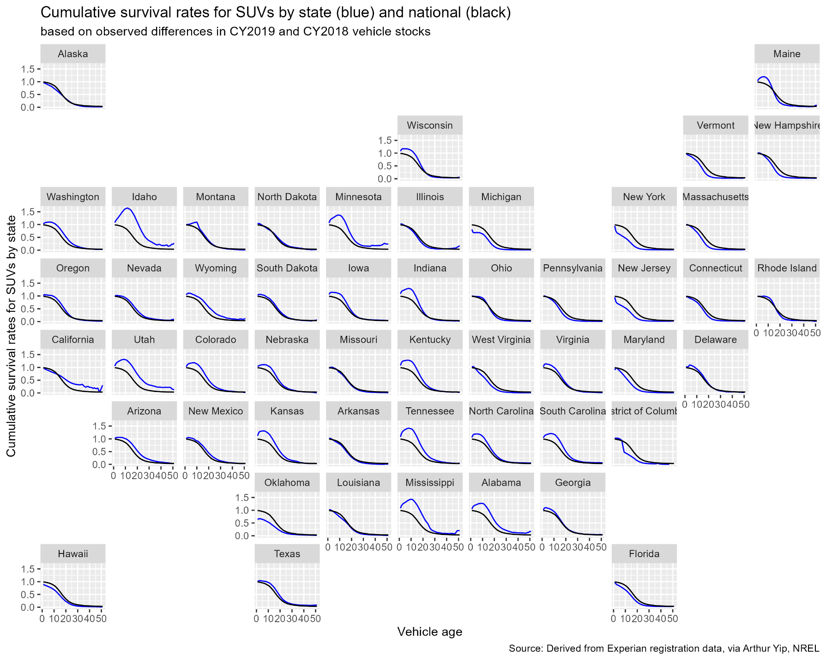
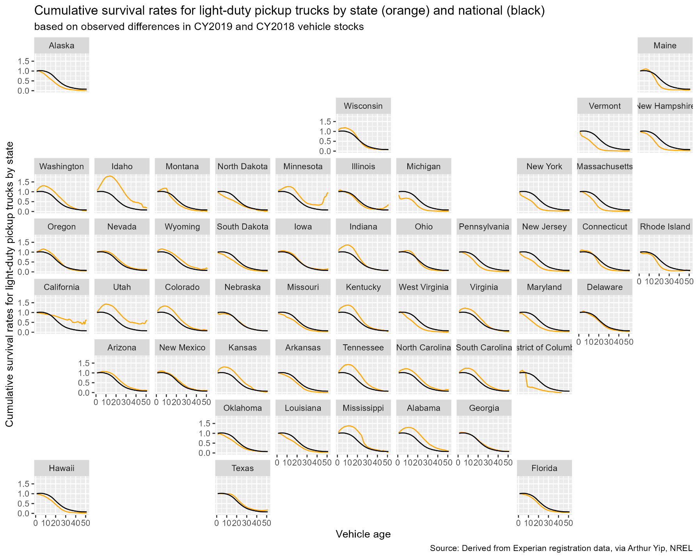
Appendix C. Data Sources for Exploratory Analysis of State Vehicle Net Survival Rates
Using lasso

- Personal Income, GDP and Employment: Bureau of Economic Analysis (BEA), 2024. “BEA Data, GDP and Personal Income”, Table SASSummary State annual summary statistics, state personal income, GDP, consumer spending, price indexes and employment. Accessed at https://apps.bea.gov/itable/?ReqID=70&step=1#eyJhcHBpZCI6NzAsInN0ZXBzIjpbMSwyOSwyNSwzMV0sImRhdGEiOltbIlRhYmxlSWQiLCI2MDAiXSxbIk1ham9yX0FyZWEiLCIwIl1dfQ== . Real GDP in millions of chained 2017 dollars, personal income in millions of constant 2017 dollars, total employment in number of jobs. File: State_GDP_Pinc_Jobs_Pop Excel Workbook.
- Median Income: Bureau of Economic Analysis (BEA), 2024. Distribution of Personal Income, State Data and Documentation, Download detailed files for all states. Table “Personal Income Inequality Metrics by State”. Accessed at https://www.bea.gov/data/special-topics/distribution-of-personal-income.
- Land Area of State (for calculating population density): U.S. Census Bureau, State Area Measurements and Internal Point Coordinates 2010, accessed at https://www.census.gov/geographies/reference-files/2010/geo/state-area.html.
- Salt Use on Roads: Clear Roads, State Winter Maintenance and Data and Statistics, Additional Calculated Statistics – By Year”, 2018-2019. Note: data are missing for several states in the southern U.S. Accessed at https://www.clearroads.org/winter-maintenance-survey/.
- Driving Age Population: U.S. Census Bureau, Annual Estimates of the Civilian Population by Single Year of Age and Sex for the United States and States: April 1, 2010 to July 1, 2019 File: 7/1/2019 State Characteristics Population Estimates, Table SC-EST2019-AGESEX-CIV.
- Urban and Rural Populations by State: U.S. Census Bureau, P2 DEC Demographic and Housing Characteristics, All States within the United States, Puerto Rico and Island Areas. Accessed at https://data.census.gov/table?q=P2&g=010XX00US,$0400000&d=DEC%20Demographic%20and%20Housing%20Characteristics.
- Interstate Traffic Congestion: TRIP, “America’s Interstate Highway System at 65: Meeting America’s Transportation Needs with a Reliable, Safe & Well-Maintained National Highway Network – June 2021”, https://tripnet.org/reports/americas-interstate-highway-system-at-65-june-2021/.
- Highway Traffic Fatalities per 100,000 Vehicle Miles of Travel: U.S. Department of Transportation, Federal Highway Administration (FHWA), Highway Statistics 2018, Table F-10 (fatalities by state) and Table VM-2 (vehicle miles by state) and VM-4 (distribution of vehicle travel by state and vehicle type).
- Education: U.S. Census Bureau, American Community Survey, Educational Attainment by State 2017. Data file ACSSE2017EDUCATIONBYSTATE, created using the Census Bureau’s table creation tool at https://data.census.gov/table.
- Vehicle Miles per Light-Duty Vehicle: U.S. Department of Transportation, Federal Highway Administration, Highway Statistics 2018, Table MV-1 State Motor Vehicle Registrations, MV-9 Truck and Truck Tractor Registrations, VM-2 and VM-4.
- Rate of leasing new vehicles: Experian, M. Zabriski, “State of the Automotive Finance Market”, Q4 2024, Q4 2023 and Q4 2020 reports.

This manuscript was supported and authored in part by authors at Oak Ridge National Laboratory, operated by UT-Battelle, LLC, under contract DE-AC05-00OR22725 with the US Department of Energy (DOE) and in part by authors at the National Renewable Energy Laboratory, operated by Alliance for Sustainable Energy, LLC, for the U.S. DOE under Contract No. DE-AC3608GO28308. The publisher acknowledges the US government license to provide public access under the DOE Public Access Plan (https://www.energy.gov/doe-public-access-plan).
This research was supported by Oak Ridge National Laboratory managed by UT-Battelle, LLC for the U.S. Department of Energy under contract No. DE-AC05-00OR22725, and by the National Renewable Energy Laboratory, operated by Alliance for Sustainable Energy, LLC for the U.S. Department of Energy under contract No. DE-AC36-08GO28308. The content of this report reflects the views of the authors and does not necessarily represent the views of the University of Tennessee, Oak Ridge National Laboratory, the National Renewable Energy Laboratory, or the U.S. Department of Energy.
Net exports of used passenger cars and light trucks from the U.S. to other countries are not considered in this analysis because they are not identified in our data and because they are a small fraction (0.3%) of U.S. car and light truck registrations (U.S. Dept. of Commerce, 2025; FHWA, 2023).
Market research on the average lifetime of vehicles by state can be found on the internet (e.g., Junk Car Reaper, 2024).
In our empirical context, we define vehicle types by age and body style. However, our theory and modeling can be extended to alternative characteristics defining vehicle type, such as fuel type.
A household can also dispose of vehicles by donating a vehicle or giving a vehicle to a family member outside of the household. These options could lead to state-to-state vehicle migration if the entity receiving the donated vehicle or the recipient family member were located in a different state.
Currently, the used vehicle market has approximately 40 million sales annually, which is more than double the number of new light-duty vehicle annual sales (Consumer Affairs 2025, FRED 2025).
Here, the vehicle type includes the age of the vehicle.
According to data from respondents sampled during Q1 2024 in the Consumer Expenditure Survey, for respondents with household income of $100,000 or more per year, 43 percent of vehicles purchased in 2023 were 2023 or 2024 model year vehicles. For respondents with household income of less than $100,000 per year, only 28 percent of vehicles purchased in 2023 were 2023 or 2024 model year vehicles.
This happens for various reasons, such as a significant mechanical failure or irreparable damage in a traffic accident.
Parks (1977) derived a model of survival to age $a+1$ conditional on survival to age $a$, in which vehicles were scrapped when the sum of the cost of a repair plus the vehicle’s value as scrap exceeded its price. A more complete review of the vehicle scrappage literature can be found in Greene and Leard (2024a).
It is possible that the vehicle types could be further disaggregated by fuel type, e.g., gasoline, hybrid, and electric. However, scrappage rates for hybrid and especially electric vehicles do not exist for older age vehicles, which would limit our analysis to relatively young vehicles for those fuel types. Therefore, in this study, we restrict our definition of vehicle type to body style.
The complete set of state graphs are in Appendix B.
Net survival rates increasing with age around 20-25 years old could be due to several factors. At some point in a vehicle’s life, it becomes a collector’s item, giving owners an incentive to maintain the vehicle and avoid scrapping the vehicle. Another reason may be due to the heterogeneity in people’s willingness to extend the life of a vehicle. Some people may be willing to take time and effort to keep a vehicle running not because it is part of a collection, but because of a desire to maintain a machine for as long as possible.
The Energy Information Administration’s Transportation Sector Demand Model documentation states that vehicle scrappage is modeled at the level of nine U.S. Census Divisions (EIA, 2022a), however the only depictions of the scrappage functions are in a set of presentation slides which note that they are not to be cited (EIA, 2022b). Estimates of average vehicle lifetimes at the state level are available on the internet (Junk Car Reaper, 2024).
A description of the data and sources is in Appendix C. In general, data for the explanatory variables are for the 2019 calendar year or changes from 2018 to 2019. All economic data are Bureau of Economic Analysis data, and all population data are Census Bureau data for 2018-2019. 2010 data were used for state areas.
We recognize that our methodology does not support strict interpretation of significance measures as hypothesis tests.
The age of a vehicle in the available data is calculated as the calendar year minus the vehicle’s model year. Because vehicle model years do not begin on January 1 and end on December 31, but on varying dates, and because not all vehicles of a model year are sold in that model year, counts of 0 and 1-year-old vehicles do not produce meaningful estimates of net survival rates and were excluded from the analysis.
We recognize that our method does not allow strict interpretation of significance levels as tests of hypotheses.
Because several model formulations were estimated before settling on the final formulation, significance levels should not be interpreted in the usual way as tests of null hypotheses but rather as indicators of the strength of the correlations between the independent variables and the dependent variable.
The Stata “estat vif” procedure calculated variance inflation factors of 1.16 to 2.78 for the continuous variables other than density, indicating that multicollinearity is not a concern for those variables. VIF values for year and COVID fixed effects were also within acceptable levels. As would be expected, state and age fixed effects had VIF values well above 10 (typically 20 to 30), and the VIFs for the age fixed effects increased with increasing age. The VIFs for density also exceeded 20 due to its strong correlation with the state fixed effects. Such results are typical in regression models when there are a large number of fixed-effect coefficients and are generally not concerning.
Showing all states, vehicle types and ages would be excessive, so we created a spreadsheet with three worksheets containing the results for each vehicle type. In each worksheet the curves for any state and year can be brought up by entering the state abbreviation (e.g., AL for Alabama) and year (e.g., 2021 for 2020 to 2021). Five states can be graphed at one time, as in the graphs below.
The COVID fixed effects differ by vehicle class but not by state.
We tried using factor analysis to create independent variables however, the resulting factors did not appear to us to have meaningful interpretations.

